# COMMISSIONER'S CORNER

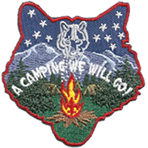

The Cub Scout Roundtable Planning Guide is not issued yet. I have seen drafts of the 12 sessions and the material has promise. The Task Force is not assigning months to the sessions, they are allowing each CS RTC to decide which session works best each month. Baloo’s Bugle will continue to use the Pack meeting Themes and Core Values found at <http://www.scouting.org/Home/CubScouts/Leaders/CubmasterResources/PackMeetingPlans.aspx> . Judy and Dave will put out a schedule of which sessions we will support each month once the CS RT PG is issued.

**Can you connect “the two dots” below??**

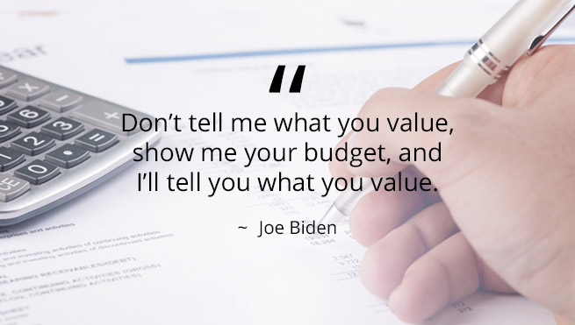

**Nothing tells your child you care more than choosing to be with him.**

*Parent’s Little Book of Wisdom.*

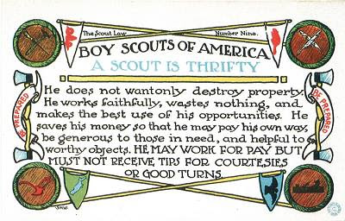

# TABLE OF CONTENTS

COMMISSIONER'S CORNER 1

TABLE OF CONTENTS 2

CORE VALUES 2

THRIFTY QUOTES 3

BIOGRAPHY 4

FRUGALITY HALL OF FAME 4

BENJAMIN FRANKLIN 4

THOUGHTFUL ITEMS 7

Prayers 7

Character for a Character 7

CUB SCOUT TIPS 8

First Time Camping Guide: 8

6 Ways to Prepare for Your First Time Camping 8

CUB SCOUT COOKING 9

TEACHING THE SCOUT OATH & LAW 11

DEN MEETING TOPICS 17

CHARACTER COMPASS 17

THEME RELATED ADVENTURES 18

PACK MEETING THEMES AND PLANS 18

PACK MEETING THEMES 19

UPCOMING MONTHS 20

CUBMASTER THOUGHTS 21

YOUR FIRST PACK MEETING 21

WEBELOS 23

WEBELOS CAMPOUTS 23

PLANNING THE CAMPOUT 23

WEBELOS CAMPING GUIDELINES 25

October Crazy Holidays 26

HOLIDAY HIGHLIGHTS 30

SPECIAL OPPORTUNITIES 32

MESSENGERS OF PEACE 32

CUB GRUB 33

MY SCOUT SHORTS. 38

**Waste neither time nor money,   
but make the best use of both**

*Benjamin Franklin*

# CORE VALUES

**The Core Value for this month is the 9th point of the Scout Law - THRIFTY**

**The core value highlighted this month is:**

October's point of the Scout Law, **THRIFTY,** will use the theme, **A CAMPING WE WILL GO.**

**A SCOUT IS THRIFTY**A Scout works to pay his way. He uses time, property, and natural resources wisely.

**HOW DOES “A CAMPING WE WILL GO” RELATE TO THIS POINT OF THE SCOUT LAW?**

Everyone loves a campfire—gathering together to share silly songs, thoughtful stories, and (perhaps)

gooey s’mores. This month, discover the fun of camping with Cub Scouts, whether it happens indoors at your regular meeting place or outdoors at a Scout camp. Camping doesn’t need to be complicated or expensive; it can be made simple by reusing and repurposing items you already have. Be sure to include an opportunity for Tigers to participate in a song or a skit during this month’s meeting to complete the Tigers in the Wild Adventure.

**Per our Founder, Lord Baden-Powell**

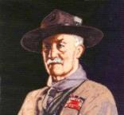

***Note –*** *The original Scout Law published in 1908 had nine points. In 1910, the BSA added Brave, Clean, and Reverent. In 1911 B-P added* ***Clean*** *to his original list.*

**A SCOUT IS THRIFTY   
A SCOUT IS THRIFTY**, that is, he saves every penny he can, and puts it in the bank, so that he may have money to keep himself when out of work, and thus not make himself a burden to others; or that he may have money to give away to others when they need it.  *(Scouting for Boys, 1908)*

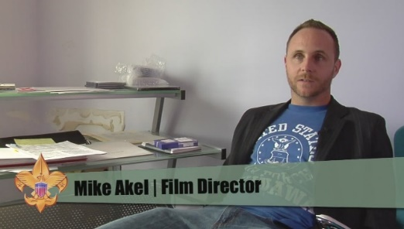

 In this video, the "Believe It Live It" team profiles a team of teachers who made a movie for their school with their own money. Go to URL: <https://www.youtube.com/watch?v=Efm2jXGbPTM&t=17s>

# THRIFTY QUOTES

*Quotations contain the wisdom of the ages, and are a great source of inspiration for Cubmaster’s minutes, material for an advancement ceremony or an insightful addition to a Pack Meeting program cover.*

I'm not cheap, I'm thrifty. ― Kym Whitley

Be thrifty, but not covetous. ― George Herbert

**It is thrifty to prepare today for the wants of tomorrow. - Aesop**

Good friends, good books, and a sleepy conscience: this is the ideal life. ― Mark Twain

I believe that thrift is essential to well-ordered living.   
- John D. Rockefeller

Cannot people realize how large an income is thrift?   
- Cicero

Frugality may be termed the daughter of Prudence, the sister of Temperance, and the parent of Liberty.   
- Samuel Johnson

Thrift means that you should always have the best you can possibly afford, when the thing has any reference to your physical and mental health, to your growth in efficiency and power. - Orison Swett Marden

He who does not economize will have to agonize.   
- Confucius

Frugality is misery in disguise. - Publilius Syrus

We are not to judge thrift solely by the test of saving or spending. If one spends what he should prudently save, that certainly is to be deplored. But if one saves what he should prudently spend, that is not necessarily to be commended. A wise balance between the two is the desired end. - Owen Young

**Many people take no care of their money till they come nearly to the end of it, and others do just the same with their time. –  
Johann Wolfgang von Goethe**

Thrift is not an affair of the pocket, but an affair of character. - S.W. Straus

Thrift comes too late when you find it at the bottom of your purse. - Seneca

Thrift was never more necessary in the world's history than it is today. - Francis H. Sisson, "Capital Needs for American Industrial Development," 1920

Whatever thrift is, it is not avarice. Avarice is not generous; and, after all, it is the thrifty people who are generous. - Lord Rosebery

The thrift that does not make a man charitable sours into avarice. - M.W. Harrison

Industry, thrift and self-control are not sought because they create wealth, but because they create character. -- Calvin Coolidge

A bargain ain't a bargain unless it's something you need. - Sidney Carroll, A Big Hand for the Little Lady

By sowing frugality we reap liberty, a golden harvest. - Agesilaus

Being frugal does not mean being cheap! It means being economical and avoiding waste.-   
Catherine Pulsifer

Shopping secondhand is like a treasure hunt. It takes time to learn how to bargain shop, but you can become a money-saving thrift store shopper by planning ahead and being prepared.- Sara Noel

Frugality includes all the other virtues. –Cicero

We are not to judge thrift solely by the test of saving or spending. If one spends what he should prudently save, that certainly is to be deplored. But if one saves what he should prudently spend, that is not necessarily to be commended. A wise balance between the two is the desired end. –Owen D. Young

Being a smart shopper is the first step to getting rich. –Mark Cuban

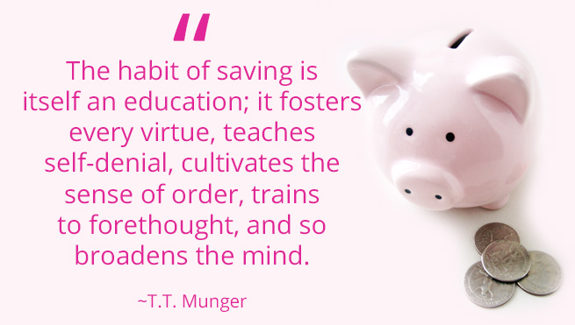

# BIOGRAPHY

## FRUGALITY HALL OF FAME

The 14 Most Interesting Frugal People

While looking for a person to highlight this month for Thrift, I found the site listed above, The Frugality Hall Of Fame – The 14 Most Interesting Frugal People, at <http://www.criticalcactus.com/most-interesting-frugal-famous-people/>. So if you want someone different. Or just want to see who is listed and why, check it out. I found it very interesting (As Arte Johnson would say on Laugh In.)

The #1 person on the list is Benjamin Franklin. His bio clip follows. I had highlighted him for Thrifty in May of 2015 so did want to use him as the main person again.

The others are –

**John D. MacArthur,** the founder of Bankers Life.

**Hetty Green,** a Quaker and the richest woman in American in the 1870s.

**Rose Kennedy,** the mother of John, Bobby, and Teddy Kennedy.

**Ronald Read** of Battleboro, Vermont. An unassuming man, Read was the first in his family to finish high school, and worked as a gas station attendant and a janitor until his retirement at age 75. He was so frugal, he drove a second-hand car, gathered his own firewood, and used safety pins to keep his coat closed when the buttons fell off. His appearance and demeanor was so shabby that one time, while having lunch at a local coffee shop, a stranger anonymously paid for his meal, assuming Read was down on his luck and couldn’t afford it. Even his attorney, Laurie Rowell, admitted to the press that the last time she had a meeting with Read, “he parked far away in a spot where there were no meters so he could save the coins.” However, when he died at 92 he was revealed to be a multimillionaire, having amassed more than $8 million by successfully playing the stock market and investing wisely. His own family was unaware of his wealth, stating that their only clue that he was accumulating vast riches was the fact that he read the Wall Street Journal religiously. His stock market savvy and simple spending habits paid off, and upon his death he was generous enough to donate approximately $6 million to his local hospital and library

**Carlos Slim Helu,** Mexican Entrepreneur

**Mark Zuckerberg,** Founder of Facebook

**David Cheriton,** Early investor in Google, technologist, college professor. Named one of "Top Ten Cheapskate Billionaires," by Business Insider.

**Michael Bloomberg,** former Mayor of New York City and communications mogul.

**Zong Quighou,** Chinese soft drink company founder

Ingvar Kamprad, IKEA Furniture founder

**Warren Buffett,** the "Oracle of Omaha." Creator of Berkshire Hathaway Co.

**Kiera Knightley,** the leading lady in the Pirates of the Caribbean movie franchise.

**Vincent Kartheiser,** Played Pete Campbell on Mad Men

**BENJAMIN FRANKLIN**

The First American

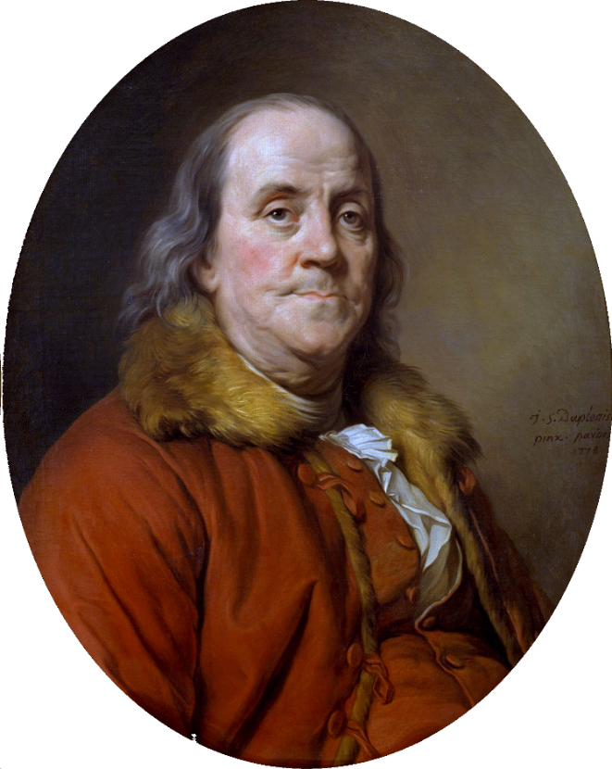

*(This article reprinted from May 2015   
issue of Baloo's Bugle)*

Benjamin Franklin (1706 - 1790) a Founding Father of the United States and a multitalented individual. Franklin was an author, printer, political theorist, politician, postmaster, scientist, inventor, civic activist, statesman, and diplomat. As a scientist, he is known for his work with electricity. As an inventor, he is known for the glass armonica, lightning rod, bifocals, and the Franklin stove, and many more. He facilitated created Philadelphia's fire department and a university.

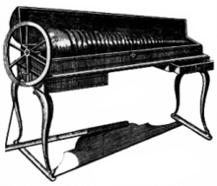  
**Glass Armonica***Spinning glass bowls on a single shaft are arranged to play music with the lower notes (larger bowls) to the left and higher notes (smaller bowls) to the right.*

Franklin earned the title of ***"The First American"*** for his early and indefatigable campaigning for colonial unity. He spoke in London and France for the colonies. He exemplified the young American nation. Franklin was foundational in defining the American way of life uniting **thrift**, hard work, education, community spirit, self-governing institutions, and opposition to political and religious authoritarianism. He was described by Walter Isaacson, as "the most accomplished American of his age and the most influential person in inventing the type of society America would become."

*“Having been poor is no shame,   
being ashamed of it is.” B. Franklin*

Franklin, always proud of his working class roots, became a successful newspaper editor and printer in Philadelphia. He published Poor Richard's Almanack and The Pennsylvania Gazette *(which later became The Saturday Evening Post)*.

He played a major role in establishing the University of Pennsylvania and was elected the first president of the American Philosophical Society. Franklin became a national hero in America when he led the effort to repeal the unpopular Stamp Act. An accomplished diplomat, he was the American minister to Paris and was a major figure in the development of positive Franco-American relations. His efforts to secure support for the American Revolution by shipments of crucial munitions proved vital for the American war effort.

His colorful life and legacy of scientific and political achievement, and status as one of America's most influential Founding Fathers, have seen Franklin honored on many money (e.g. $100 bill); warships; place names (towns; counties); educational institutions; corporations; and, more than two centuries after his death, countless cultural references.

A delegate to the conventions for both the Declaration of Independence and the Constitution and a signer of both, Franklin is considered one of the Founding Fathers of the United States. His pervasive influence in the early history of the nation has led to his being jocularly called "the only President of the United States who was never President of the United States."

I could go one for many pages about his life –

* His inventions - the lightning rod, glass armonica, Franklin stove, bifocal glasses and the flexible urinary catheter.
* His demographic and populations studies.
* His scientific works – ocean currents, electricity, light waves, meteorology, cooling, temperature, oceanography.
* His love and practice of the arts – playing several musical instruments, playing chess, writing
* His public life – Ambassador to France, Diplomat, establishing philosophical societies, hospitals, colleges, postmaster

But let's leave these for others and look at Franklin and Thrift.



**Franklin lived his life to his Thirteen Virtues**

Franklin sought to cultivate his character by a plan of 13 virtues, which he developed early in life and practiced the rest of his life. His 13 virtues as:

* **Temperance.** Eat not to dullness; drink not to elevation.
* **Silence.** Speak not but what may benefit others or yourself; avoid trifling conversation.
* **Order.** Let all your things have their places; let each part of your business have its time.
* **Resolution**. Resolve to perform what you ought; perform without fail what you resolve.
* **Frugality.** Make no expense but to do good to others or yourself; i.e., waste nothing.
* **Industry.** Lose no time; be always employed in something useful; cut off all unnecessary actions.
* **Sincerity**. Use no hurtful deceit; think innocently and justly, and, if you speak, speak accordingly.
* **Justice.** Wrong none by doing injuries, or omitting the benefits that are your duty.
* **Moderation.** Avoid extremes; forbear resenting injuries so much as you think they deserve.
* **Cleanliness.** Tolerate no uncleanliness in body, clothes, or habitation.
* **Tranquility.** Be not disturbed at trifles, or at accidents common or unavoidable.
* **Chastity.** Rarely use venery but for health or offspring, never to dullness, weakness, or the injury of your own or another's peace or reputation.
* **Humility.** Imitate Jesus and Socrates.

You will see a large dose of **THRIFTY** in these 13 virtues under Resolution, Frugality, and Industry.

Franklin did not try to work on them all at once. Instead, he would work on one and only one each week "leaving all others to their ordinary chance." While Franklin did not live completely by his virtues, and by his own admission he fell short of them many times, he believed the attempt made him a better man contributing greatly to his success and happiness, which is why in his autobiography, he devoted more pages to this plan than to any other single point; in his autobiography Franklin wrote, "I hope, therefore, that some of my descendants may follow the example and reap the benefit." *Just as we do not expect our Scouts to keep the Oath and Law perfectly all the time but to do their best and learn from their m, 1739istakes.*

**Poor Richard's Almanack**

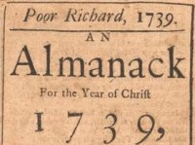

**Franklin declared 1739 as   
The Year of Thrift**

**Famous Franklin Quotes on Thrift –**

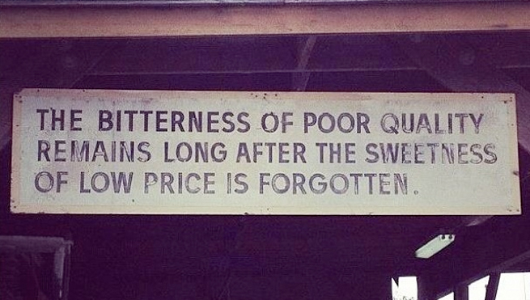

* A penny saved is a penny earned.

**The lesson:** Saving money is the number one key to building wealth and becoming financially successful.

***Note from CD –*** *Some Internet sources say this is a misattribution to Franklin. They say it goes back to the 1600's and this form (these words) originated after Franklin.*

* An investment in knowledge always pays the best interest.

**The lesson:** Never stop learning. If you have a chance to take a class, or further your education, go for it. Better yet, study things that interest you on your own time.

* Having been poor is no shame,   
  being ashamed of it is.

**The lesson**: Remembering the crushing weight of debt or poverty might be just the motivation you require to sustain your personal frugality and ensure a better future for yourself and your family.

* He that is of the opinion money will do everything may well be suspected of doing everything for money!

**The lesson:**You should be in charge of your money; it shouldn’t be in charge of you.

* Rather go to bed without dinner than to rise in debt

**The lesson:**Don’t live beyond your means, and [get out of debt](http://www.moneycrashers.com/25-reasons-to-get-out-of-debt-today/) as quickly as possible

**Cubmaster's Minute Idea –**

Talk about Franklin for your minute and start by showing his picture by pulling a $100 bill out of your pocket!! Bet you get everyone's attention!! I don't have one but I know people who do. Or you could print one side from a .jpg on the Internet.

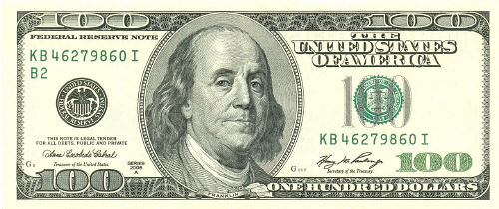

**Other THRIFTY Quotes from Benjamin Franklin**

* Haste makes waste
* Speak little - do much
* Necessity never made a good bargain
* If you’d know the value of money,   
  go and borrow some
* Beware of little expenses:   
  a small leak will sink a great ship
* If you know how to spend less than you get,   
  you have the philosopher’s stone
* Content makes poor men rich,   
  Discontent makes Rich men poor
* Avoid dishonest gain:  
  No price can recompense the pangs of vice
* No gains without pains
* Light Gains, heavy Purses
* He that drinks fast, pays slow
* He that waits upon fortune,   
  is never sure of a dinner
* Diligence is the mother of good luck
* Don’t judge men’s wealth or piety,   
  by their Sunday appearances
* Work as if you were to live 100 years,   
  Pray as if you were to die tomorrow
* Lost time is never found again
* Well done is better than well said
* If Passion drives,   
  let reason hold the reins
* Wise men learn by others’ harms,   
  fools by their own





**A Penny saved,   
is a penny earned**

*Benjamin Franklin*

# THOUGHTFUL ITEMS

## Prayers

Oh, Great Creator of Heaven and Earth and the all thing beneath Thy great sky. Let us use these things to help our fellows and teach our charges responsibility for Thy bounty. Let us care for the treasures of this earth and waste not a thing**. Amen**

Industry, thrift and self-control are not sought because they create wealth, but because they create character. Calvin Coolidge

## Character for a Character

*Scouter Jim, Bountiful, UT*

In the 25th Chapter of Matthew in the New Testament, Jesus Christ gives the parable of the talents. The two wise servants invested their talents and doubled their value.

I would like to introduce you to a neighbor of mine, who understands that concept. When he was young, about Tiger Cub age, he knocked on my door. In his hand he had a roll of specialized tape used by heating contractors. It was a roll of aluminum tape used to seal gaps in heating ducts.

“Will you trade me this for something better?” was his question.

I found something among my stuff to satisfy this request. He went from neighbor to neighbor, trading up until he got a prize he could keep.

When he was older, New Scout Patrol age, he wanted to attend a Basketball Camp at a local University, but he needed to raise the funds as his parents could not afford the registration. His grandmother had an unused solar greenhouse. As we talked, we decided that I would purchase some tomato seeds for him. In exchange, he would provide me with what plants I needed for the coming season. The others he planted he could sell to others. I was quite literally giving him “seed” money for his venture.

He went door to door selling the promise of tomato plants to all the neighbors, with the same determination he has used when he traded me the tape as a young Cub. By the time he was finished delivering his plants and tithing his profits; he had paid for his camp, supplied half the town with tomatoes, and had a few dollars spending money. He had also earned three merit badges in the effort.

Can we teach our charges the values of this young man? We must!

# CUB SCOUT TIPS

## First Time Camping Guide:

**Beginner Camping for   
the Whole Family**

<https://cubscouts.org/this-makes-first-time-camping-not-so-scary/>

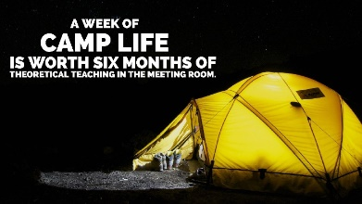

Let’s get real – you don’t have to be a “camping person” to camp! I certainly wasn’t, but that changed after great outdoor experiences and the sense of accomplishment I got from properly preparing.

To the masses of aspirational first-time campers and, dare I say, camping-haters who want to make sure their kids still spend valuable time outdoors, we’ve got your back. Just because you don’t know how to set up a tent yet doesn’t mean your kid is doomed to a life devoid of outdoor skills (and neither are you).

Many have come before you and braved a weekend outside for their first-time camping. You can, too. In fact, you’ll probably enjoy it.

Here are a few tips that recently got me through an extended camping adventure (*trust me*, if I can camp, you’re definitely going to be able to).

## 6 Ways to Prepare for Your First Time Camping

1. **Opt for an organized campsite**. [National parks](https://www.nps.gov/hfc/cfm/carto.cfm) and [Scout camps](http://www.scouting.org/LocalCouncilLocator.aspx) are a good choice. Finding locations like these mean you’ll know ahead of time if you have access to fire rings and restrooms. Just be sure to use the contact information of your chosen campsite to ask the camp ranger or other camping personnel all your questions ***(pro tip: definitely ask about toilets/showers and plan accordingly).*** You’ll also want to make sure there’s not a burn ban in place if you plan to have a campfire.
2. **Invest in a few pieces of quality gear**: a tent, a sleeping bag that suits the temperature you’ll be camping in, a sleeping pad, a head lamp, and a reliable lantern are my top picks for investment pieces. These little comforts mean a lot when you’re sleeping outdoors or navigating to the bathroom at night. Plus, mid to high-quality versions of these items last, so your investment does pays off.
3. **Use this**[**checklist**](https://scoutingmagazine.org/2017/08/family-camping-gear-ages/) to consider everything you want to bring. For instance, if you’re planning to cook canned goods during your camping trip, you need to have a can opener on hand. Avoid leaving essentials behind by formulating a packing list in the days leading up to your trip. (Hint: essentials for your trip will vary based on what you’re cooking, weather, region, etc. A checklist like [this one](https://scoutingmagazine.org/2017/08/family-camping-gear-ages/) allows you to sort through what you need and what you can leave behind). ***Checklist -*** <https://scoutingmagazine.org/2017/08/family-camping-gear-ages/>
4. **Know how to navigate to your campsite**. There’s a good chance you’ll lose cell service on your way. Print out or write driving and walking directions before you set off for your camping adventure. Also let family or friends who aren’t camping with you know where you’re camping and when you plan to return.
5. **Do research and practice runs ahead of time**. If you want to study up on your tent’s online setup video, make sure you watch it before you’re out in the elements (remember you may have no cell service). You could even take notes and should definitely do a test run in your backyard to make sure you’re ready to camp sans-Google.
6. **Scope out your campsite when you arrive**. Look for hazards, like swift water, steep drops, and poisonous vegetation. Set up your tent away from these hazards and make sure your camping party knows to avoid them too.

**If you’re still not convinced your inner-camper exists** here’s a great way to dip your toe in the camping waters: Get involved in Scouting. When you camp with Scouters (these are the adult volunteers in the Boy Scouts of America), you have a huge knowledge-base at your fingertips.

From setup basics to five-course campfire meals, camping with Scouters helped me bridge the gap from first-time camping to confident camper.

To find Scouters near you, head to [Be a Scout](https://beascout.scouting.org/) ([www.beascout.org](http://www.beascout.org)) and let a local pack know your family is interested in a first-time camping trip.

## CUB SCOUT COOKING

***Bill Smith****, the Roundtable Guy*

When we think of Cub Scout or even Boy Scout cooking, we usually thing of how they do it – grilling stuff over a fire, roasting marshmallows, firing up Dutch ovens and other exotic techniques. However chefs would tell you that much of their efforts entail using those three essentials of food preparation: Menus, Shopping Lists and Recipes. If you can’t handle those basic documents, producing meals become a problem.

A short time ago my wife, Shirley, and I were invited to help staff a [B.A.L.O.O. training](http://www.scouting.org/filestore/training/pdf/510-033(17)BALOO.pdf) in nearby Fort Gatlin District. Training Chairman Corb Sarchet wanted us to help out with the lunch and also handle the cooking demo in the Round Robin in the afternoon. We hadn’t worked on a BALOO in some years so we got the latest manual (not many changes, we noticed) and buckled down to get ready.



**The 10th Purpose of Cub Scouting**

Now I am a big advocate that learning to cook is an important part of that last aim of Cub Scouting: Preparation for Boy Scouts. The experiences a boy can learn by completing his core and elective Adventures in the Tiger, Wolf, Big Bear and Webelos programs will do him in good stead when he joins a troop. Cooking and especially eating on a camp out is important.

When I was a Scoutmaster, we welcomed Webelos into our troop. They understood and followed Scouting ideals, they were familiar with advancement and, of course, we loved getting parents who were used to helping out.

It was an added plus if the boys could cook. In their troop, the Scouts I was with did all the meal preparation. The patrols planned their menus, bought the food, prepared it and ate as patrols. We adults tended to contribute to the costs, and we then participated as guests.

**Menus**

For B.A.L.O.O., our first step was to plan our menu for the demonstration. We decided to feature foods boys were most likely to want to eat: pizzas, banana boats, baked apples, and also to throw in a couple of simple challenges: baked potatoes and scrambled eggs. The pizza and banana boats – kid-friendly food - turned out to be hits.

Menus get pretty good treatment in Cub Scouts starting with Tiger Bites (With your adult partner, plan and make a good snack choice or other nutritious food to share with your den.) This is just a simple job but it’s a start. It gets more complex in the Wolf Adventure, Finding Your Way, there is another snack to prepare. The Bear Picnic Basket Adventure has a lot of food prep. And A Webelos Scout has to earn Cast iron Chef.

Making lists of what we will be eating is another aspect of good planning. Cub Scouts should get lots of practice in this important skill. Choose foods kids like so that cooking and meal preparation is popular and fun.

The important point of making a menu is to visualize the end result of the whole cooking deal – to set down in writing the goals of the job ahead. When Boy Scouts go camping they need to answer the question: What are we going to eat out there? If they fail to plan ahead then eating becomes something of a problem.

**Recipes**

Just listing an item in a menu is a far cry from making it suddenly appear. Going from menus to recipes – listing each ingredient and then all the preparation and cooking instructions is a learned skill.

For BALOO, Shirley and I turned each of our menu items into individual recipes. The pizza recipe in the BALOO handout called for ingredients like English muffins, pepperoni, sauce, cheeses and various vegetables. It also described how to prepare the ingredients – slice, the muffin, spread the sauce, slice the veggies etc. Then it called for a [“drug store wrap”](https://www.youtube.com/watch?v=QRWyz675OUI) in foil and cooking over hot coals for a specified time. There are lots of details never mentioned in the menu here.

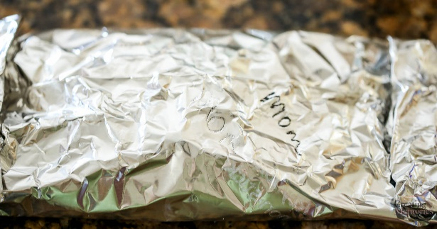

By the time a Cub Scout graduates from Webelos, he should have lots of experience going from menus to recipes. Bear Picnic Basket Adventure is full of opportunities to learn. By then he should becoming familiar with terms like mix, slice, chop and blend. He should know the differences between fry, bake grill and simmer, and have a nodding acquaintance with measurements like cup, tsp, pinch and quart.

A lot of this learning should be done in the family kitchen before he tries if outside. Scouts who have learned to cook at home have much less grief cooking on a camp out.

Most of all though, he should understand the importance of organizing the workplace. Most menus list all the ingredients and even the utensils before getting to the instructions. This makes organizing easier. Have everything set and ready – what chefs refer to as *mise en place*. It makes following the recipe a lot less troublesome especially when cooking outdoors over a fire.

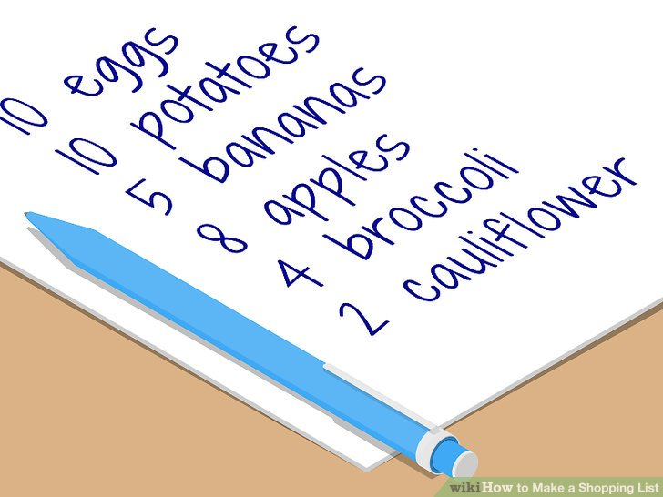

**Shopping Lists**

Teach boys to shop. It’s an important skill that will be useful life long – starting in Boy Scouts.

Not too long ago I ran into one of our neighborhood Webelos dens at our local supermarket. Near the front of the store, the two leaders stood observing the antics of their charges but the boys were doing all the work. They were pushing two carts around loading them up with provisions for an upcoming camping adventure. I watched them comparing prices, reading ingredient lists and debating the merits of various brands. These boys will do well in the troop they join.

Turning menus and recipes into a shopping list isn’t easy. Like other skills it requires proper demonstrations, good coaching and lots of practice. Parents should be taking their Cub Scout sons shopping, especially for those items to be used for Tiger, Wolf and Bear Adventure requirements. Help them prepare the shopping lists – What do we already have? What do we need? How much?

The Scout troop I worked with never ate in a dining hall at camp. They always cooked and ate as patrols. Occasionally they attended a camp where food was supplied but mostly they bought their own. Going shopping with them before a long term camp was fun – something between a circus and an episode of [*Good Eats*](http://www.foodnetwork.com/good-eats/index.html)– without Alton Brown.

Sure they made mistakes, purchasing wrong items, forgetting essentials but they were good cooks and could improvise. I remember one patrol that discovered out on the Appellation Trail that there was no syrup for their pancakes. Just plain forgot. One enterprising Scout suggested they make their own out of hot water, sugar and Tang! It turned out to be a pretty good substitute.

It is a real joy to camp with Scouts who can cook. Patrols often develop their own specialties – one I recall that regularly did roast beef with Yorkshire pudding in a Dutch oven. There was at least one Scout who turned out soufflés over a fire. He would do it at our family picnics just to amaze the adults.

So make it a point to teach your Cub Scouts and Webelos to cook. Cook things as dens and encourage parents to do it at home. Many packs hold cake baking festivals for the boys. Pack campouts are always opportunities for some outdoors cooking. It will be a valuable skill for any boy to acquire and will make his Boy Scout experience more fun and more valuable. And, as celebrity chef Alton Brown says: “A culinary talent I skillfully used later as a way to get dates in college.”

What are **YOU** going to do now?

***The best gift for a Cub Scout.......  
 ......get his parents involved!***

Check Out -

**Outdoors With Kids  
Ten Camping Commandments to   
Build Excitement Outdoors**

In **Part II – Training and Admin Helps** of this Month’s **Baloo’s Bugle!!**

# TEACHING THE SCOUT OATH & LAW

**TO CUB SCOUTS**

**Just Remember –**

**The first two Bobcat Requirements state –**

1. Learn and say the Scout  
 Oath, **with help if needed.**

2. Learn and say the Scout Law,   
 **with help if needed.**

A Cub Scout must Do His Best but his best may not be perfection and may be better or not as good as another Cub Scout's best.

**SING "TRUSTY TOMMY"**

**TRUSTY TOMMY**

[WWW.USSCOUTS.org](http://WWW.USSCOUTS.org)<http://usscouts.org/songs/songbk1a.asp>

[Tune – Yankee Doodle](http://usscouts.org/songs/songbk1a.asp) *It is song #14 in the songbook*

Trusty Tommy was a Scout

Loyal to his mother,

Helpful to the folks about,

And friendly to his brother.

Courteous to the girls he knew,

Kind unto his rabbit,

Obedient to his father, too,

And cheerful in his habits.

Thrifty saving for a need,

Brave, but not a faker,

Clean in thought and word and deed,

And reverent to his Maker.

Check it out on You Tube -   
Real Scouts singing -   
<https://www.youtube.com/watch?v=Y0y4O5E51_k>

Professionals signing -   
<https://www.youtube.com/watch?v=d_4SaiMC4KQ>

**ANOTHER SONG –**

Jennifer, a Webelos leader suggested singing the Scout Law to the tune of "Ten Little Indians."

A Scout is  
Trustworthy, Loyal,  
Helpful, Friendly,  
Courteous, Kind,  
Obedient, Cheerful,  
Thrifty, Brave,  
Clean and Reverent  
This is the Scout Law.

It took me a few tries but I got it down, and so can you!! Try it.

And a Big Heap How to Jennifer!!

Here is a Karaoke version that show the original words but plays only music   
<https://www.youtube.com/watch?v=mbVUayytvMY>

And a sung version -   
<https://www.youtube.com/watch?v=k0SkWCCWrF8>

I would not try and fit it to this version:  
<https://www.youtube.com/watch?v=r9-OrJnt1O4>   
*(It is the Beach Boys version!!!!)*

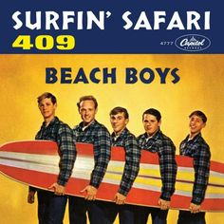

Other new ideas welcome – Just write Judy and I at the address shown on Baloo's Bugle's Home Page!!! **CD**

**Scout Law Word Search**

*Pack 200, Cary, NC*

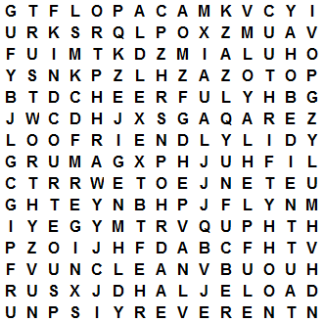

**Find the 12 Points of the Scout Law -**

TRUSTWORTHY LOYAL HELPFUL   
FRIENDLY COURTEOUS KIND  
OBEDIENT CHEERFUL THRIFTY  
BRAVE CLEAN REVERENT

**The Scout Law Puzzle**

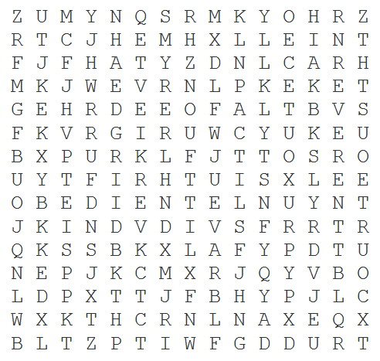

TRUSTWORTHY LOYAL HELPFUL   
FRIENDLY COURTEOUS KIND  
OBEDIENT CHEERFUL THRIFTY  
BRAVE CLEAN REVERENT

*This is one of my favorite scout law games. The kids love the competition and they learn it fast. JOE*

**Scout Oath Word Search**

*Commissioner Dave &* [*www.superkids.com*](http://www.superkids.com)

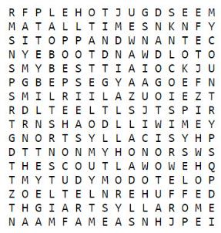

**Find phrases from the Scout Oath -**

ON MY HONOR I WILL DO

MY BEST TO DO MY DUTY

TO GOD AND MY COUNTRY

AND TO OBEY THE SCOUT LAW

TO HELP OTHER PEOPLE

AT ALL TIMES TO KEEP MYSELF

PHYSICALLY STRONG

MENTALLY AWAKE AND

MORALLY STRAIGHT

**The Emoji Scout Law**

By Bryan Wursten

<http://boyslife.org/the-emoji-scout-law/>

The word “emoji” means “picture letter” in Japanese, and emoji have become a popular way to communicate in texting or social media. These small images or icons are often used to quickly express an idea or emotion.

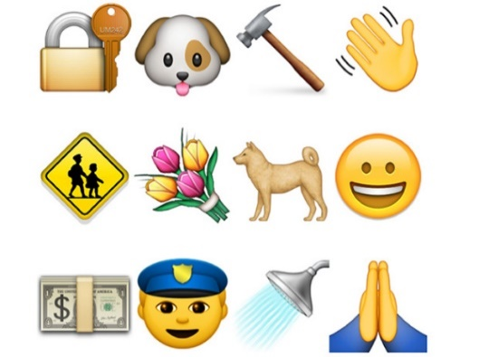

Here at Boys’ Life, we’re all about communicating, so we searched through all the standard emoji and nominated icons that we thought could illustrate each point of the Scout Law. Then we asked our readers to vote. What you see here are the top vote getters.

**Scout Law Games**

*Pack 200, Cary, NC*

**

* Divide the den into two teams.
* Give each team a set of twelve 3 x 5 cards with each card having one word of the Scout Law printed on it.
* At the starting signal, have each team place the cards in the correct order of the Scout Law.
* The winning team is the team to first have their cards in the right order.
* Prepare 10 cards with phrases of the Scout Oath, too

On my Honor

I will do my best

To do my duty

To God and my Country

And to obey the Scout Law

To help other people

At all times

And to keep myself

Physically Strong, Mentally Awake,

and Morally Straight

**

**Toss!**

*Pack 200, Cary, NC*

* Turn each of the 12 Scout Law cards over on the grid so that the number side is up
* Place the cards in proper order – 1 through 12.
* In turn have each boy toss a bean bag or alternative onto one of the squares.
* The boy who threw the bag must now say the point of the law on which their bean bag landed.
* If they do not know it, the next in line may answer.
* Continue until the grid is completed.

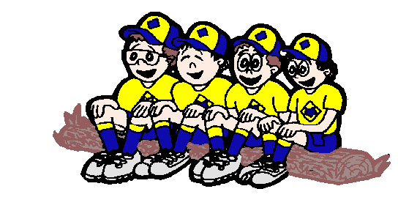

**Scout Law Circle**

*Pack 200, Cary, NC*

**Version #1 -**

* Form the boys into a circle with the Den Chief in the middle.
* Den Chief is to randomly point to a boy who gives the first point of the Scout Law (Trustworthy).
* Den Chief then points to another boy who is to give the next point in order (Loyal).
* If a boy does not give the correct response by the time the den chief counts to five, he step backwards and sit down. He is out of the game.
* Play continues until there is only one boy left, or until everyone is stumped.
* If you get through the Law once, start over again until all are eliminated that are going to be eliminated.

**Version #2 -**

* Form the boys into a circle with the Den Chief in the middle.
* Den Chief is to randomly point to a boy who gives the first point of the Scout Law (Trustworthy).
* Den Chief then points to another boy who ist o give the next point in order (Loyal).
* If a boy does not give the correct response by the time the den chief counts to five, ask for a volunteer to tell the boy the correct answer. Then see if the boy who was stumped knows the next point. If not repeat process.
* Then move onto another Scout.
* Keep everyone involved. Hopefully they will absorb the Law and the proper order by participating.
* Provide small prizes (candies?) for those who answer correctly.
* If you get tired of going through the Law, start having them say the Oath.



**Pantomime, Charades, or Acting Out-**

*Pack 200, Cary, NC*

* Yes, make practice into a game of charades! Boys love to act silly.
* You could even have a session where they acted out the opposite of the law. For some reason, showing the wrong behavior sure is fun!
* When it is his turn, give a Scout a 3x5 card having one word of the Scout Law printed on it.
* The scouts could also put on an impromptu skit involving the Scout Law.

**CLIMB A LADDER**

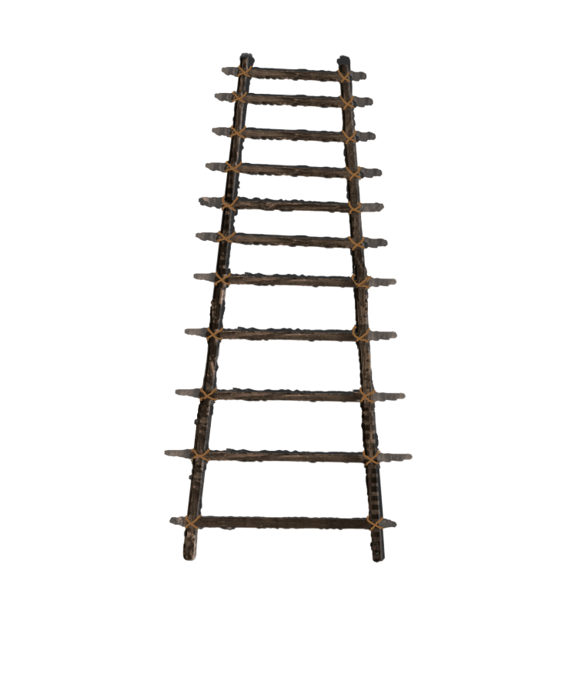

Take (or make) a ladder with 12 sections. Label each section with one of the parts of the Scout Law (Trustworthy, Loyal, Helpful, Friendly, Courteous, Kind, Obedient, Cheerful, Thrifty, Brave, Clean, Reverent). Scouts (Scout and Adult Partner for Tigers) sit by the ladder. A Cub rolls/tosses a ball (or tosses a bean bag). The Cub must explain in his own words the part of the Scout Law where the object landed.

**Build a Scout Law Ladder**

*Boyslife.org*

**~~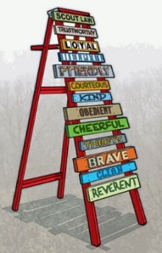~~**

**What You’ll Need**

* A wooden ladder about 7′ or 8′ tall
* 13 wooden boards
* Saw
* Paint for each board and the ladder
* Paint, tape, sticks, stencils, letters cut from thin wood or stick-on letters to create the Scout Law words
* Different-sized paint brushes for painting the ladder, boards and letters
* 52 finishing nails or wood screws to attach the boards to the ladder
* Hammer or screwdriver

**What You’ll Do**

1. Cut the boards to length, using a crosscut saw to cut across the grain and a rip saw to cut with the grain. Each board should be long enough to span the width of the ladder, but they can be different widths and lengths. Make sure all 13 boards will fit on the ladder from top to bottom.

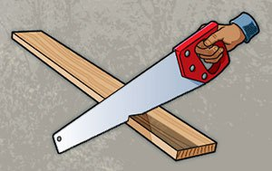 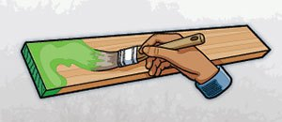

1. Paint the ladder and boards.
2. Choose method for putting words on each board

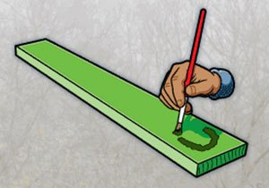 

1. Attach the completed boards to the ladder. If you use screws to attach the boards to the ladder, predrill the screw holes so wood doesn’t split.
2. Your Scout Law ladder is now ready for display

**Build a Scout Law / Oath Plaque or Game**

**START BY SCALING BACK THE LADDER–**

**Instead of boards** –

Use craft sticks *– either Popsicle stick size or tongue depressor size.*

Use 1" lath strips

**Instead of painting on the words** –

* Use labels, or
* Uncooked Alphabet Pasta, or
* Print with Sharpies
* or similar

**Instead of nailing –**

Glue them together

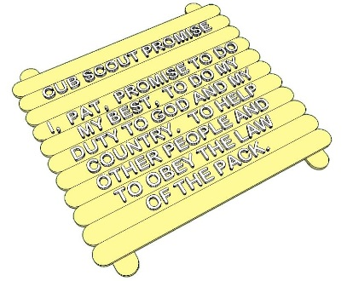

Drill/punch holes and lace or thread them together

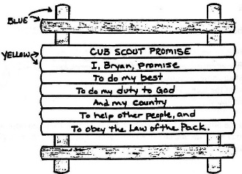

Leave a set loose and challenge the boys to put them in the right order!!

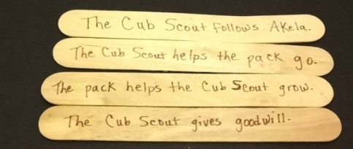

*Sorry for dated examples but One Oath/One Law has not been around long enough to Cub Scout crafts on the net yet!!!*

**Or using boards** – put cup hooks on them and have boys assemble the law in order. Bigger is better for boys!!!

**ROLL TWO FUZZY DICE**

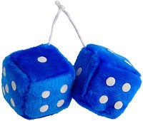

Get a pair of fuzzy dice (Novelty Shop, Oriental Trading). There are 12 numbers same as 12 points of Scout Law. Playing Options –

**Option #1 -**

Roll one die and either the roller or the whole den in unison recite the points of the Law up to the number. If you roll a one, they should say, “A Scout is trustworthy.” If you roll a five, they should go all the way through courteous. Have all the Cubs primed to help if the reciter stumbles. To make it easier, just roll one die until the boys master the first 6 points. Then roll both.

**Option #2 –**

A Cub rolls the dice. Either he figures out what part that number is (11 = Clean) or a leader tells him. Then he says a little about what that part means to him.

**ROLL THE DICE GAME**

This requires one dice. Each boy rolls the dice and depending on what number comes up, he performs one of the requirements of the Bobcat Award. Score points for each boy who does the task correctly. **Add some flavor - let a roll of 5 yield an extra roll.**

1 = Scout Oath   
2 = Scout Law   
3 = Cub Scout motto   
4 = Cub Scout salute   
5 = Cub Scout handshake   
6 = Cub Scout sign and meaning

*Check out* <http://www.boyscouttrail.com/tests/arrow-test.asp> *for an on-line Arrow of light test!*

**RELAY RACE**



As Baden-Powell says, “A boy is not a sitting-down animal.” By turning the Law into a relay race, you can let Scouts burn off some energy while learning something in the process. Here’s how:

Make two sets of 12 cards where each card displays one point of the Law.

Put the cards in each set in random order and place them in two piles at the front of the room.

Divide the den into two teams and have each team line up facing one pile of cards.

When you say “go,” the first boy on each team runs to his team’s pile of cards, picks what he thinks is the first point of the Law and sticks it on the wall using masking tape. He then returns to tag the next player, who runs up, chooses the second point, and places it below the first. Continue in this manner until one team has all the points on the wall in the correct order.

If a team has the points in the wrong order, let them take extra turns, moving one card per turn. The first team with all the points posted in the right order wins.

**SCOUT LAW SPEED TEST**

* Using a permanent marker, write each of the 12 parts of the scout law on a separate tongue depressor or ice cream bar stick.
* Mix them up, throw them on a table.
* Each Webelos Scout takes a turn to put them in order (i.e., Trustworthy, Loyal, Helpful, etc.)
* Using a stop watch, time each scout.
* The scout who is the quickest, wins.

**CRAFT STICK HANGING**

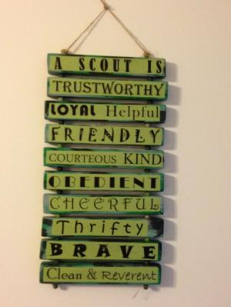

Have the Cubs each take 13 craft sticks. On the first one they write "A Scout Is" Then they put one part of the Scout Law on each of the other 12. You can play a game getting the points in order or they can create a hanging like the one in the picture. When you say “go,” the first boy on each team runs to his team’s pile of cards, picks what he thinks is the first point of the Law and sticks it on the wall using masking tape. He then returns to tag the next player, who runs up, chooses the second point, and places it below the first. Continue in this manner until one team has all the points on the wall in the correct order.

***Other new ideas welcome –   
Just write Judy and I the address shown  
on Baloo's Bugle's Home Page!!! CD***

# DEN MEETING TOPICS

Remember – Boys want to be active!!   
See, too, that they earn their awards   
***(Never say GET. You get sick, you do not get awards – You earn awards. A little CD Philosophy)***.

**Big Rock Ideas** – suggestions for Big Rocks that fit Interest Topics or seasonal activity. The years next to an item (e.g. 13-14) is the Roundtable Planning Guide where the suggested Big Rock is published. All Big Rocks are on-line at <http://www.scouting.org/scoutsource/Commissioners/roundtable.aspx>



# CHARACTER COMPASS

**OCTOBER -**ADVENTURES with a **CHARACTER COMPASS** pointing to **THRIFTY:**

**TIGER –**

* Backyard Jungle (Core)
* Floats and Boats (Elec)

**WOLF –**

* Council Fire (Core)
* Code of the Wolf (Elec)

**BEAR –**

* Fur Feathers & Ferns (Core)
* Make It Move (Elec)

**WEBELOS CORE –**

* Cast Iron Chef (Core)

**ARROW OF LIGHT CORE –**

* Building a Better World (Core)
* Camper (Core)

**WEBELOS & AOL ELECTIVES –**

* Art Explosion (Elec)

~~~~

**NOVEMBER -**ADVENTURES with a **CHARACTER COMPASS** pointing to **REVERENT:**

**TIGER –**

* My Family’s Duty to God (Core)
* Sky Is the Limit (Elec)

**WOLF –**

* Duty to God Footsteps (Core)

**BEAR –**

* Fellowship & Duty to God (Core)

**WEBELOS CORE –**

* Duty to God and You (Core)

**ARROW OF LIGHT CORE –**

* Duty to God in Action (Core)

**WEBELOS & AOL ELECTIVES –**

* Into the Woods (Elec)

# http://www.orgsites.com/in/pack3092/tsalute.jpgTHEME RELATED STUFF

# THEME RELATED ADVENTURES

All Adventures are fun. –

**GOOD ADVENTURES FOR “A CAMPING WE WILL GO”**

**TIGER –**

* Tigers in the Wild (All requirements pertain to Outdoors) Core

**WOLF –**

* Call of the Wild (All requirements pertain to Outdoors) Core
* Howling at the Moon (3 & 4 – Campfire) Elec

**BEAR –**

* Bear Necessities (All requirements pertain to Outdoors) Core
* Roaring Laughter (#6 – Campfire Run Ons) Elec

**WEBELOS –**

* Cast Iron Chef (1, 4, & 5 – Outdoor Cooking) Core

**ARROW of LIGHT –**

* Camper (Obviously all requirements pertain to Camping) Core
* Scouting Adventure (3 & 4 – Prep for and go on a camping trip with a BS Troop) Core

**WEBELOS ELECTIVES –**

* Castaway (#1 – Several things to be done on a camping trip) Elec







# PACK MEETING THEMES AND PLANS

[*www.scouting.org*](http://www.scouting.org)

**From National's Website for the new plans using the Core Values based on the Scout Law:**

Here are a few thoughts to consider around these new pack meeting plans. First, there is a plan for each month that corresponds with a point of the Scout Law. In addition, each plan has a theme to help make the pack meeting even more fun! The plans do not have to be used in a specific order.

**Tips for Utilizing the Plans**

* Pack meeting plans do not have to be done in any special order, but it is recommended that you include all of the points of the Scout Law each year. The pack planning meeting would be a good time to determine the order.
* There are pack meeting plans for multiple years posted on the website. It is your pack's choice of which one to select from each point of the Scout Law for each year.
* Pack meetings should not last longer than an hour. Adjust the plan to make it fit within the time. Research and experience tells us that Cub Scouts have a hard time sitting still for that long. Keep the meetings fun, active, and engaging.
* If you are comfortable with a costume to fit the theme of the meeting, go for it!
* Importantly, keep it simple and make it fun.
* The following required adventures have a requirement that suggests or requires completion at a pack meeting. Please plan accordingly as part of your annual program planning process. Work with your den leaders to plan when these activities will take place.

**Tiger**

* **Tigers in the Wild,** requirement 5. Participate in an outdoor pack meeting or pack campout campfire. Sing a song and act out a skit with your Tiger den as part of the program.
* **Games Tigers Play,** requirement 3. Make up a new game, and play it with your family or members of your den or pack.

**Wolf**

* **Council Fire,** requirement 6c. Create a den project from recyclables for a pack meeting.

**Bear**

* **Grin and Bear It**, requirement 2. Working with the members of your den, organize a Cub Scout carnival and lead it at a special event.
* **Grin and Bear It**, requirement 3. Help younger Cub Scouts take part in one of the events at the Cub Scout carnival.

**Webelos**

* **Stronger, Faster, Higher**, requirement 5. With adult guidance, lead younger Scouts in a fitness game or games as a gathering activity for a pack or den meeting.

**Arrow of Light**

* **Building a Better World (if chosen**), requirement 10b. Set up an exhibit at a pack meeting to share information about the World Friendship Fund.

Check them out at:   
<http://www.scouting.org/Home/CubScouts/Leaders/CubmasterResources/PackMeetingPlans.aspx>



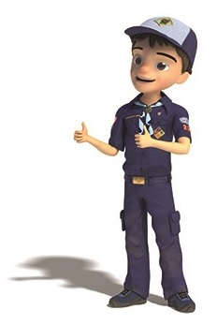

# PACK MEETING THEMES

Kim, the chair of the task force, says **"I do want to stress that the focus is still the Core Value and the theme is just there as an enhancement. Pack meeting theme plans are specifically crafted to bring out the important points of the Core Value in a fun way."**

|  |  |  |
| --- | --- | --- |
| **2017–2018 Pack Meeting Plans** | | |
| Sep | Courteous | [How the West Was Fun](http://www.scouting.org/filestore/cubscouts/pdf/2017/310-842(17)_September_Courteous.pdf) |
| Oct | Thrifty | [A-Camping We Will Go](http://www.scouting.org/filestore/cubscouts/pdf/2017/310-842(17)_October_Thrifty.pdf) |
| Nov | Reverent | [Cubs Give Thanks](http://www.scouting.org/filestore/cubscouts/pdf/2017/310-842(17)_November_Reverent.pdf) |
| Dec | Kind | [Paying It Forward](http://www.scouting.org/filestore/cubscouts/pdf/2017/310-842(17)_December_Kind.pdf) |
| Jan | Helpful | [Jobs, Jobs, Jobs](http://www.scouting.org/filestore/cubscouts/pdf/2017/310-842(17)_January_Helpful.pdf) |
| Feb | Cheerful | [Abracadabra!](http://www.scouting.org/filestore/cubscouts/pdf/2017/310-842(17)_February_Cheerful.pdf) |
| Mar | Trustworthy | [Cub Scout Investigators](http://www.scouting.org/filestore/cubscouts/pdf/2017/310-842(17)_March_Trustworthy.pdf) |
| Apr | Loyal | [Cubs in the Future](http://www.scouting.org/filestore/cubscouts/pdf/2017/310-842(17)_April_Loyal.pdf) |
| May | Friendly | [Treasure Hunters](http://www.scouting.org/filestore/cubscouts/pdf/2017/310-842(17)_May_Friendly.pdf) |
| Jun | Obedient | [Wheel Into Summer](http://www.scouting.org/filestore/cubscouts/pdf/2017/310-842(17)_June_Obedient.pdf) |
| Jul | Brave | [Home of the Brave](http://www.scouting.org/filestore/cubscouts/pdf/2017/310-842(17)_July_Brave.pdf) |
| Aug | Clean | [Destination Parks](http://www.scouting.org/filestore/cubscouts/pdf/2017/310-842(17)_August_Clean.pdf) |

**If you are using a paper copy the link to all the   
Pack Meeting Plans is:**

<http://www.scouting.org/Home/CubScouts/Leaders/CubmasterResources/PackMeetingPlans.aspx>

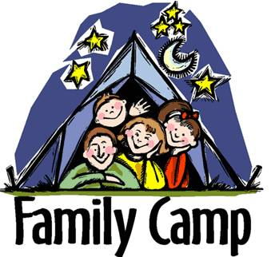

program updates banner

# **UPCOMING MONTHS**

**For October,** the suggested Pack Meeting theme, **A Camping We Will Go**, emphasizes the Scout Law point, **THRIFTY.**



Here are some months that would have Camping and Outdoors Information. Note how the what Cubs can do in the outdoors ahs increased over the years. The early themes are all backyard based:



**REMEMBER –**

Earning your CYBER Chip is an annual requirement -

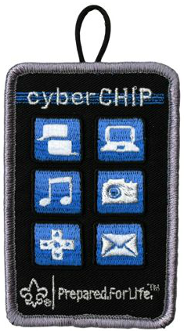

**For November,** the suggested Pack Meeting theme, **CUBS GIVE THANKS**, emphasizes the Scout Law point, **REVERENT.**

**For November,** the suggested Pack Meeting theme, **A Cubs Give Thanks**, emphasizes the Scout Law point, **REVERENT.**

|  |  |  |
| --- | --- | --- |
| **Month** | **Year** | **Theme** |
| **REVERENT** (Themes for former CV Faith are listed here) | | |
| November | 1942 | Thanksgiving |
| November | 1952 | Faith of his Fathers |
| December | 1960 | Guiding Stars |
| November | 1974 | Pilgrims |
| December | 2005 | Faith, Hope & Charity |
| December | 2007 | Celebrations Around the World |
| April | 2011 | Faith |
| April | 2012 | Faith |
| April | 2013 | Cub Scouts Give Thanks |
| April | 2015 | Soaring the Skies |
| December | 2015 | Winter Wonderland |

|  |  |  |
| --- | --- | --- |
| **Month** | **Year** | **Theme** |
| **Cub Scouts Give Thanks** | | |
| November | 1942 | Thanksgiving |
| November | 1952 | Faith of his Fathers |
| December | 1960 | Guiding Stars |
| November | 1974 | Pilgrims |
| November | 1980 | Thanksgiving - Living and Sharing |
| November | 1984 | Turkey Day |
| November | 1992 | Turkey Day |
| December | 2000 | What do You do at Holiday Time? |
| November | 2003 | Pilgrims of Plymouth Rock |
| December | 2005 | Faith, Hope & Charity |



# **CUBMASTER THOUGHTS**

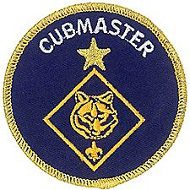

**YOUR FIRST PACK MEETING**

**OF THE FALL**

*Mark Diienno, Cubmaster Emeritus, Garden State Council, and a wise old OWL   
who has earned the Unit Leader Award of Merit*

**The first Pack Meeting.** How can this be? It seemed like yesterday we had our June Pack Meeting, and September seemed like an eternity away. Well, that eternity has passed, the days are getting alarmingly shorter, and the Program year is upon us.

The first Pack Meeting is crucial in setting the tone for your unit. It will be the information exchange meeting between your pack leaders, and the families who make up your unit.

This is the golden opportunity to let families know what is expected of them. Dues, uniforming (and hopefully assistance in uniforming to those families who may be in need in your unit), medical forms, and recruiting of scout parents to assist in various activities, are among the various topics that should be discussed with the Pack as whole.

Here you have a captive audience. Here you have a chance to motivate the families to step up as it were, and assist in making your unit the best it can be.

So, how do you accomplish this task and keep your Cub Scouts engaged in a quality scouting experience?

**As with all Pack Meetings, the seven parts of Pack Meeting should be utilized.**

There should be pre planning to insure that the meeting will run smoothly and stick to time constraints. (Yes, especially the first one should be between 60 – 75 minutes(an hour to an hour and a quarter, even though the author is hard pressed to get any of them done in an hour and a half.)

**There should be an opening.**Now this is the first meeting. It should be spectacular. I do something in my unit that I find very moving and motivating especially to the boys.

We line them up outside.

While they are lining up, I ask the families, “watch any sports lately?? Have you found yourself cheering loudly for men to succeed? Men you don’t even know? Well outside are a bunch of young men, about to embark on a challenging year learning skill to allow them to be better.

If we can cheer for men we don’t know on our television, how much more can we cheer for the boys who will ultimately be our futures. Cheer like they just won the World Series, or The Super Bowl…or better yet cheer them because they are **Our Sons**. Clap until the last boy comes enters. The look on the boys’ faces will tell you how wise a Cubmaster you are.

Once the Pledge of Allegiance, Law and Oath are said, (and after a quick great song by that same Cubmaster ), You should not overlook this golden opportunity to recognize the boys for what they accomplished over the summer.

Some went to Day Camp, Some went to Cub or Webelos Weekend or Cub or Webelos Resident Camp.

Perhaps you have dens who have earned the summertime Den Award, or if you fortunate you have 75% of your dens earning this award and there your unit is recognized as well.

All of these awards must be obtained prior to the meeting of course.

At this point we split the Pack Meeting.

The boys on one side of the meeting place, and the parents on the other.

The boys will be experience any number of scout activities, such as:

* A wildlife reserve presenting the importance of wildlife conservation, (hopefully with animals on display).
* The local Police or Fire Department coming and explaining their various duties in keeping our communities safe.
* A local troop could presenting various scouting experiences such as knot tying, first aid, camp set up or all of the above.

The sky is the limit.

**While the boys are engaged it is the perfect time to discuss with the parents, the program year and what is expected of them.**

Different Chartered Orgs have different obligations that Cub Scout Packs must meet just to be able to meet there.

For instance, our unit is chartered to a Catholic Parish. Therefore, our Pack must have all parents and leaders fingerprinted and background checked if they wish to spend an overnight with the unit.

This is the perfect time to inform the scout parent of these obligations.

Discussing the program year and potential needs in parent involvement are also important topics.

As Cubmaster, it is crucial to motivate your unit families to contribute their time, talent, and treasures, to insure a successful year.

Perhaps have all leaders and committee introduce themselves to show the diversity within your unit and insure others to follow the footsteps of volunteerism. Encourage dialogue by asking questions and inviting comments and opinions.

Separating the unit in this manner is a very effective tool in getting your program year off the ground.

A well-informed unit is in a better position to succeed, and a quality program is attainable.

Timing is essential, do be careful not to run to far over the time allotted. Even parents lose their focus if this runs on and on.

**Bring everyone back together for the closing.**

This will be your first Cubmaster MInute of the year. Use it to motivate the boys to get the most out of the program and empower the Scout parents to contribute to this unique opportunity to help shape tomorrow’s leaders.

If the first meeting is done well, the entire unit will leave with a feeling of hope. They will be excited at the possibilities that lie before them.

And your leadership will enjoy the assistance and support of the Scout Families that together will make your Cub Pack experience the best it can be.

Retire the colors and leave knowing your first quality pack meeting was realized, and get ready for a great scouting program year.

For more help be sure to check out –

[](http://www.cubmaster.org)

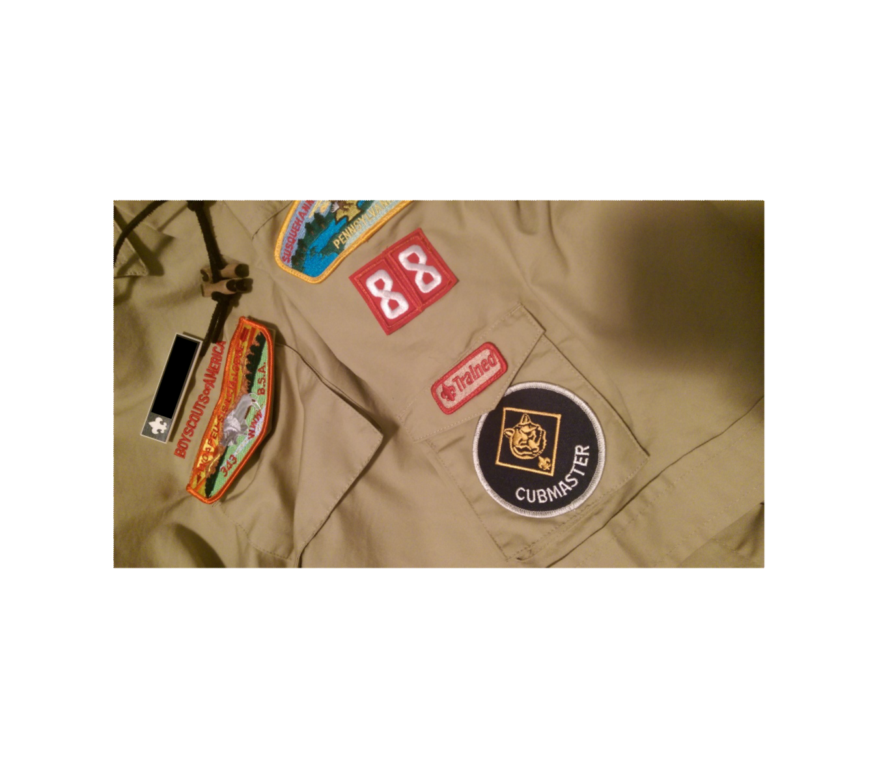

# WEBELOS





**Always an S -** Webelos always ends with an S whether talking about one Webelos Scout or a den of Webelos. It is an acronym – **WE**’ll **BE** **LO**yal **S**couts. As the CS RT Commissioner who mentored me says – "If you don’t have an S at the end – then there is nothing to which to be loyal." **(She was the N5-690-17 Wood Badge Scoutmaster!!)**

**The Two Dens –** The correct names for the two years of the Webelos Program are the **Webelos Den** and the **Arrow of Light Den**. In the National Scout Shop where I work part-time, at Roundtables, and almost everywhere I go, I hear people refer to Webelos I and Webelos II. Webelos I and II are a little like Class A and Class B Uniforms. They are terms many Scouts and Scouters use but are not found in any material printed by the BSA. I am looking for why the BSA chose the terms they use and will let you know when I know. But please use the correct terms so all will understand. Thank you. CD

# WEBELOS CAMPOUTS

*Adapted From Several Training Syllabi*

*Note: For Traditional units, Webelos Scouts / Dens means Webelos (4th grade) and Arrow of Light (5th grade) Scouts / Dens. For LDS Units where the Webelos experience is the 12 months a Scout is 10 years old, it is all inclusive.*

## PLANNING THE CAMPOUT

**Introduction**The Webelos den overnight campout is an important part of the Webelos camping program in preparing boys for Boy Scouting. These campouts usually last for one or two nights and may be repeated several times during a boy's time as a Webelos Scout. It is here that bridges can be built to help span the gap between Cub Scouts and Boy Scouts.

Webelos den camping should give boys a taste of camping to whet their appetites for their future Boy Scout experience. It does not include the rugged type of camping done in the troop. Webelos den campouts do not include backpacking. The campouts should be held in areas readily accessible by auto, and are always parent or guardian-and-son activities.

**Planning Steps**Planning a Webelos den overnight campout is simply being able to "see" with your mind's eye things that are going to happen. As you live the experience in your mind, you can write down the things that need to be done. A written plan is essential so that nothing important is overlooked and everyone knows his or her responsibilities

**Who Attends?**Be sure the participants understand that this is a parent-and-son event and every Webelos Scout must have a parent (or other adult) accompanying him on the overnight campout. Each parent has a share of responsibility in planning and carrying out the campout. If a parent or guardian is unable to attend, the family should make arrangements with another adult family member or with the parent of another Webelos Scout (but not the Webelos den leader) to accompany the boy. At all times, a boy must be under the direct supervision of an adult.

**Where Is It Held?**Campsites might include local Scout camps or a nearby city, county, state, or federal facility (a state park or county forest preserve, for example). The campsite should be located near a parking area since Webelos den overnight camping cannot include backpacking. Ensure that the camp facility provides safe water, toilet facilities, garbage disposal, and fire sites.

It is a good idea to have a backup plan in case of bad weather.

**How Do We Get There?**Review the safety rules for transporting Scouts in the *Guide to Safe Scouting* and the *Cub Scout Leader Book*

Be sure there are enough cars to hold all of the boys and adults as well as the camping gear.

**What Do We Need?**

* **Tents.** Some families will have tents or can borrow one from a neighbor or friend. Or tents for the den can be borrowed from a Boy Scout troop.
* **Food, cooking equipment, utensils, and bags for disposing of trash and garbage.** These can be brought from home by each boy-parent team or purchased for the whole den after a planning session with the parents.
* **Program materials**, depending on what activities are planned.
* **Personal equipment for boys and adults.** In the Webelos Handbook, the Arrow of Light Required Adventure Camper has list of items to bring on a campout. It is in three parts – Scout Basic Essentials for every outing, Overnight Gear, and Optional Items. Additional items may be added to the list, depending on your program, time of year, and expected weather.

**Campout Preparation Activity**There are three major campout preparation steps. These preparation steps are

* **Prepare yourself.** What do you, as a Webelos Den Leader, need to know and do?
* Make reservations.
* Check fire regulations.
* Attend Webelos Leader Outdoor Training.
* Enlist the help of others.
* **Prepare the boys.**   
  What do the boys need to know?
* Teach the rules about outdoor fire safety.
* Review the Outdoor Code.
* Teach the boys basic knots.
* Teach the boys basic first aid.
* Plan campfire program activities.
* Send home a list of items the Webelos Scout and his parents should bring on the campout
* **Prepare the adults.**   
  What do the parents need to know?
* Date of campout
* Location
* Time and place to rendezvous
* Schedule of events for the campout
* Campout menu
* Equipment list required for the campout
* Health and safety

**Campout Activities**her is a partial list of possible campout activities:

* **U.S. Flag** - Always fly the U.S. flag at camp. Have a ceremony as you raise and lower it.
* **Work on Adventures** - The campout is a good time for boys to complete requirements for Adventures that have requirements to be completed in the outdoors.
* **Campfire Program** - This is an exciting part of a campout. Plan it carefully so that it will be successful. Remember that campfires should be positive experiences, and no put-downs or negative skits should be allowed.
* **Outdoor Games** - Games are great fun on campouts. Take care to use games that boys and adults can play together. The *Cub Scout Leader How-To Book* has many games appropriate for a campout. The section on team-building games includes games that adults and boys can play together as the games don't depend on speed or size.
* **Worship Service -** You may plan your campout so that campers are home in time for Sunday or Sabbath worship. If not, be sure to include a vesper or "Scouts' Own" service as part of the camp out program. Because Scouting is nonsectarian, the worship service should be nondenominational and attendance optional but encouraged. Sample Scouts Own service program are available on-line.
* **Fishing -** If there is a lake or stream nearby, fishing is a good campout activity. Be sure the adults have fishing gear and licenses. Stress conservation-keep only the fish you plan to eat and release all others.
* **Swimming or Boating -** If facilities are available, these are good activities that everyone will enjoy. Remember to use Safe Swim Defense when swimming and Safety Afloat when boating.

**Summary**The Webelos den overnight campout will be a big event in the life of each boy. Be sure it is a good experience for him. A poorly planned, poorly run campout can discourage a boy from participating in future outdoor activities. Well-planned campouts will keep him interested and cause him to look forward to becoming a Boy Scout.

Parents and guardians, too, must be happy on campouts. If they have a successful, pleasurable, and interesting campout experience, they are more likely to participate in, and bring their Webelos Scout to, the next campout.

WEBELOS CAMPING GUIDELINES

*Adapted from Cub Scout Camping Policies,   
Suffolk County Council*[*http://www.sccbsa.org/docs/Council/SCCBSA_Cub_Camping_Policy.pdf*](http://www.sccbsa.org/docs/Council/SCCBSA_Cub_Camping_Policy.pdf)

**Webelos Camping**Webelos den overnight campouts provide opportunities for Webelos and Arrow of Light Scouts to enjoy the increasing camping challenges offered by BSA’s progressive outdoor program, but still within the family environment of Cub Scouting. Webelos camping experiences should help prepare Webelos Scouts for the camping adventures of Boy Scouting without taking away from the type of camping they will experience as a member of a Boy Scout troop.

Webelos Dens are encouraged to have several overnight campouts each year during the spring and fall months. In colder climates, Webelos dens should not tent camp outdoors during the harshest part of the winter.The Webelos den overnight campouts are parent-son events, under the direction of the Webelos den leader. Each Webelos scout should be under the supervision of an adult, preferably his own father, mother, or guardian. If a parent or guardian cannot attend, the boy’s family should make arrangements for one of the other parents or another adult relative or friend to be a substitute at the campout. It is essential that each Webelos Scout is under the supervision of an adult and that every adult has a share of the responsibility for the campout. Webelos dens are encouraged to participate in joint overnight campouts with a Boy Scout troop; however, a parent or guardian of each Webelos Scout must still attend. These campouts are especially encouraged during the Arrow of Light (fifth-grade) year. These campouts, conducted with an individual troop for the purpose of strengthening ties be-tween the pack and troop, are to be held separate from any district or council Boy Scout activities (e.g. Camporees). The Webelos Den Leader should discuss these guidelines with the host troop for coordination.

Because of the responsibilities of a Webelos Leader on an overnighter, a Webelos Leader should not accept responsibility for a Webelos Scout whose parents or guardian cannot attend. Youth protection guidelines that state that the only adult that can sleep in a tent with a scout is his parent or legal guardian are in effect. Webelos den campouts are not open to siblings.

Webelos Scouts should be experiencing family-type camping, as opposed to the more challenging type of camping that they will be experiencing as Boy Scouts. A location that has a tested water supply, toilets, cooking facilities, space for pitching tents, and an in-door activity area would be appropriate for a Webelos Den overnight campout.

If you expect the Scouts and parents bring family camping type equipment, consider choosing a campsite located near a parking area or that is vehicle accessible. Family camping equipment tends to be heavy and difficult to carry any distance. In selecting the location for a Webelos overnight campout, remember that Webelos Scouts should not experience Boy Scout-type camping on the overnight. Webelos overnights do not include backpacking. Webelos overnight camping at Boy Scout camporees and/or events is not a BSA-approved activity.

When tents are used, no youth will stay in the tent of an adult other than his parent or legal guardian. When housing other than tents is used, separate housing must be provided for male and female participants. Permits for campouts are issued at the Council Service Center. Webelos dens use the Local Tour Permit Application.

# October Crazy Holidays

*Claralyn, Golden Empire Council,   
Adapted from* <http://holidayinsights.com/moreholidays/index.htm>  
[http://www.brownielocks.com/month2.html](http://www.brownielocks.com/month2.html%20)

**October is:**



* [**Adopt a Shelter Dog Month**](https://www.petfinder.com/pet-adoption/dog-adoption/october-is-adopt-a-shelter-dog-month/)

*Our daughter and we work with   
Adopt a Boxer Rescue.* ***CD***

* **American Pharmacist Month**
* [Apple Month](http://usapple.org/)

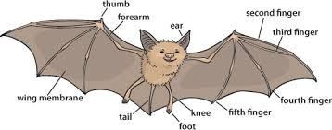

* [Bat Appreciation Month](http://www.thebirdfoodstore.com/2015/10/09/october-is-bat-appreciation-month/)
* **Breast Cancer Awareness Month**
* [**Bullying Prevention Month**](http://www.pacer.org/bullying/nbpm/)
* Celiac Disease Awareness Month
* Celebrating The Bilingual Child Month



* [**Clergy Appreciation Month**](https://blogs.lcms.org/wp-content/uploads/2009/08/cam.pdf)
* **Computer Learning Month**
* **Cookie Month**



* [Corn Month](http://wholegrainscouncil.org/whole-grains-101/easy-ways-enjoy-whole-grains/grain-month-calendar/corn-%E2%80%93-october-grain-month)



* [Country Music Month](https://www.allaccess.com/net-news/archive/story/111016/cma-celebrates-october-as-country-music-month) or [This Link](http://www.presidency.ucsb.edu/ws/?pid=6728)
* **Domestic Violence Awareness Month**



* [Down Syndrome Awareness Month](http://www.ndss.org/About-NDSS/Our-Team/Ambassadors/Goodwill-Ambassador/Straight-Talk-with-Chris-Burke/Down-Syndrome-Awareness-Month/)



* [Eat Better, Eat Together Month](https://nutrition.wsu.edu/eteb/)
* **Eat Country Ham Month**
* German-American Heritage Month
* [Global ADHD Awareness Month](http://www.adhdawarenessmonth.org/)
* Halloween Safety Month
* [International Drum Month](http://www.playdrums.com/international-drum-month/)

[](http://bpaa.com/news/articleid/32)

* [Learn to Bowl Month](http://bpaa.com/news/articleid/32)
* National Dental Hygiene Month
* **National Diabetes Month**
* National Liver Awareness Month



* National Physical Therapy Month
* **National Pizza Month**
* National Popcorn Popping Month
* [National Pork Month](http://nationalhogfarmer.com/resources/get-ready-october-pork-month)
* **Sarcastic Month**
* **Seafood Month**



* [Spinach Lovers Month](http://www.dietsinreview.com/diet_column/10/national-spinach-lovers-month-perfect-time-to-give-spinach-a-chance/)
* Squirrel Awareness Month



* [**National Vegetarian Month**](http://www.foodandnutrition.org/Stone-Soup/October-2014/Why-Celebrate-Vegetarian-Awareness-Month/)

***As a recent convert to Vegetable Based & Whole Grain eating, I highly recommend you consider this life style or at least reducing the amount of meat you eat. It was a personal choice. CD***

**Weekly Celebrations:**

* [Albuquerque International Balloon Festival](http://www.balloonfiesta.com/)   
  1-10
* [National Walk Your Dog Week](http://www.walkyourdogweek.com/) 1-7
* Universal Children's Week: 1-7



* [4H Week](http://4-h.org/professionals/marketing-resources/#!promotional-toolkits)  1-7
* Great Books Week: 1-7 (1st Full Week)
* National Carry A Tune Week: 1-7

[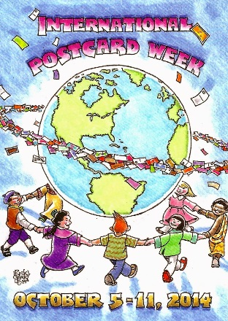](http://internationalpostcardweek.blogspot.com/)

* [International Post Card Week](http://internationalpostcardweek.blogspot.com/) 1-7

[](http://www.weavespindye.org/spinning-weaving-week)

* [Spinning & Weaving Week](http://www.weavespindye.org/spinning-weaving-week): 2-6
* [World Space Week:](http://www.worldspaceweek.org/) 4-10
* National Storytelling Weekend: 6-8
* Earth Science Week: 8-14

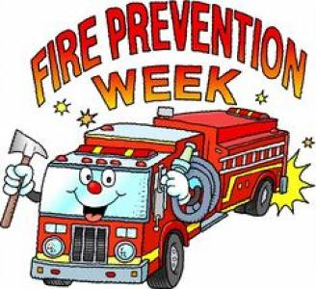

* **Fire Prevention Week: 8-14**
* World Rainforest Week: 9-15

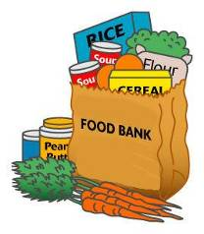

* National Food Bank Week: 15-21 (Week Always Has 16th in it, World Food Day)



* Freedom of Speech Week 16-22
* Freedom From Bullies Week: 15-21
* National Character Counts Week: 15-21
* National Chemistry Week: 22-28
* Teen Read Week: 8-14



* National Friends of Libraries Week: 15-21



* National School Bus Safety Week, 16-20
* YWCA Week Without Violence: 16-20
* National Nuclear Science Week 23-27

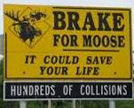

* **Give Wildlife a Brake! Week: 29-11/4**
* World Origami Days: 24-11/11
* International Magic Week: 25-31

**October Daily Holidays, and   
Special and Wacky Days:**

**7** [**International Frugal Fun Day**](http://holidayinsights.com/moreholidays/October/frugalfunday.htm)

***This sounds like a great Thrifty   
Cub Scout Idea!!***

1 [World Vegetarian Day](http://holidayinsights.com/moreholidays/October/worldvegetarianday.htm)

1 [National Homemade Cookies Day](http://holidayinsights.com/moreholidays/October/national-homemade-cookes-day.htm)

2 [National Custodial Worker Day](http://holidayinsights.com/moreholidays/October/custodialworkerday.htm)

2 [Name Your Car Day](http://holidayinsights.com/moreholidays/October/nameyourcarday.htm)

3 [National Boyfriends Day](http://holidayinsights.com/moreholidays/October/national-boyfriends-day.htm)

3 [Techies Day](http://holidayinsights.com/moreholidays/October/techiesday.htm)

3 [Virus Appreciation Day](http://holidayinsights.com/moreholidays/October/virusappreciation.htm)

4 [National Golf Day](http://holidayinsights.com/moreholidays/October/nationalgolfday.htm)



4 [National Frappe Day](http://holidayinsights.com/moreholidays/October/frappeday.htm)

4 [National Kale Day](http://holidayinsights.com/moreholidays/October/national-kale-day.htm) - first Wednesday of October

5 [Do Something Nice Day](http://holidayinsights.com/moreholidays/October/dosomethingnice.htm)

5 [World Teacher's Day](http://holidayinsights.com/moreholidays/October/worldteacherday.htm)

6 [Come and Take it Day](http://holidayinsights.com/moreholidays/October/comeandtakeitday.htm)

6 [Mad Hatter Day](http://holidayinsights.com/moreholidays/October/madhatterday.htm)

6 [Physician Assistant Day](http://holidayinsights.com/moreholidays/October/physicianassistant.htm)

6 [World Smile Day](http://holidayinsights.com/moreholidays/October/worldsmileday.htm)

7 [World Card Making Day](http://holidayinsights.com/moreholidays/October/world-card-making-day.htm)

7 [Bald and Free Day](http://holidayinsights.com/moreholidays/October/baldandfreeday.htm) (or October 14)

8 [Oktoberfest](http://holidayinsights.com/moreholidays/September/oktoberfest.htm) in Germany ends, date varies



8 [American Touch Tag Day](http://holidayinsights.com/moreholidays/October/americantagday.htm)

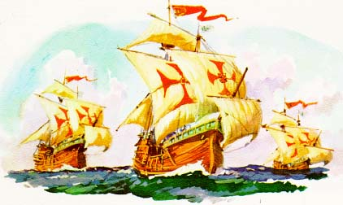

9 [Columbus Day](http://holidayinsights.com/other/columbus.htm) - second Monday of month

9 [Curious Events Day](http://holidayinsights.com/moreholidays/October/curiouseventsday.htm)

9 [Fire Prevention Day](http://holidayinsights.com/other/firepreventionday.htm)

9 [Leif Erikson Day](http://holidayinsights.com/other/erikson.htm)

9 [Moldy Cheese Day](http://holidayinsights.com/moreholidays/October/moldycheeseday.htm)

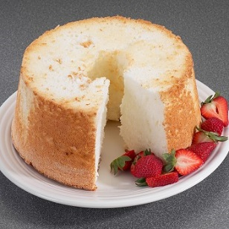

10 [National Angel Food Cake Day](http://holidayinsights.com/moreholidays/October/angelfoodcakeday.htm)

10 [International Newspaper Carrier Day](http://holidayinsights.com/moreholidays/September/newspapercarrier.htm) -date varies

11 [Emergency Nurses Day](http://holidayinsights.com/moreholidays/October/emergencynursesday.htm)- date varies

11 [It's My Party Day](http://holidayinsights.com/moreholidays/October/itsmypartyday.htm)

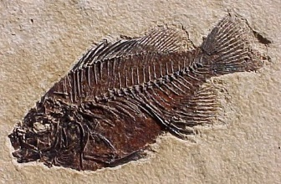

11 [National Fossil Day](http://holidayinsights.com/moreholidays/October/national-fossil-day.htm) - date varies

11 [Take Your Teddy Bear to Work Day](http://holidayinsights.com/moreholidays/October/taketeddybeartowork.htm)

12 [Cookbook Launch Day](http://holidayinsights.com/moreholidays/October/cookbooklaunchday.htm)

12 [National Gumbo Day](http://holidayinsights.com/moreholidays/October/national-gumbo-day.htm)

12 [Old Farmer's Day](http://holidayinsights.com/moreholidays/October/oldfarmersday.htm)

12 [Moment of Frustration Day](http://holidayinsights.com/moreholidays/October/momentoffrustration.htm)

13 [World Egg Day](http://holidayinsights.com/moreholidays/October/worldeggday.htm)  - second Friday of month

13 [International Skeptics Day](http://holidayinsights.com/moreholidays/October/internationalskepticsday.htm)

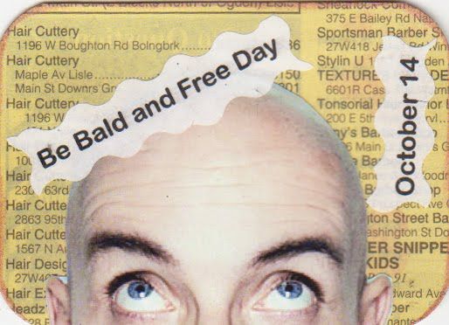

14 [Bald and Free Day](http://holidayinsights.com/moreholidays/October/baldandfreeday.htm) (Or October 7)

14 [National Dessert Day](http://holidayinsights.com/moreholidays/October/nationaldessertday.htm) - take an extra helping, or two

15 [White Cane Safety Day](http://holidayinsights.com/moreholidays/October/whitecanesafetyday.htm)

16 [Bosses Day](http://holidayinsights.com/other/boss.htm)

16 [Dictionary Day](http://holidayinsights.com/moreholidays/October/dictionaryday.htm)

17 [National Pasta Day](http://holidayinsights.com/moreholidays/October/national-pasta-day.htm) (See October 25)

17 [Wear Something Gaudy Day](http://holidayinsights.com/moreholidays/October/gaudyday.htm)

18 [No Beard Day](http://holidayinsights.com/moreholidays/October/nobeardday.htm)

19 [Evaluate Your Life Day](http://holidayinsights.com/moreholidays/October/evaluateyourlifeday.htm)

20 [Brandied Fruit Day](http://holidayinsights.com/moreholidays/October/brandiedfruitday.htm)

21 [Babbling Day](http://holidayinsights.com/moreholidays/October/babblingday.htm)

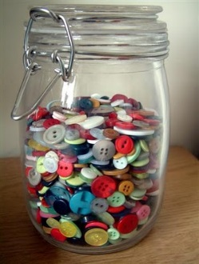

21 [Count Your Buttons Day](http://holidayinsights.com/moreholidays/October/countyourbuttonsday.htm)

21 [Sweetest Day](http://holidayinsights.com/other/sweetest.htm) Third Saturday of month

21 [National Pumpkin Cheesecake Day](http://holidayinsights.com/moreholidays/October/pumpkincheesecakeday.htm) find a recipe, too.

22 [Mother-In-Law Day](http://holidayinsights.com/other/motherinlaw.htm) - fourth Sunday in October

22 [National Nut Day](http://holidayinsights.com/moreholidays/October/nationalnutday.htm)

23 [National Mole Day](http://holidayinsights.com/moreholidays/October/nationalmoleday.htm)

23 [TV Talk Show Host Day](http://holidayinsights.com/moreholidays/October/talkshowhostday.htm)

24 [National Bologna Day](http://holidayinsights.com/moreholidays/October/nationalbolognaday.htm)

24 [United Nations Day](http://holidayinsights.com/other/unday.htm)

25 [World Pasta Day](http://holidayinsights.com/moreholidays/October/worldpastaday.htm) (See October 17)

25 [Punk for a Day Day](http://holidayinsights.com/moreholidays/October/punkforaday.htm)

26 [National Mincemeat Day](http://holidayinsights.com/moreholidays/October/mincemeateday.htm)

27 [National Tell a Story Day](http://holidayinsights.com/moreholidays/April/tellastoryday.htm) - in Scotland and the U.K.

27 [Navy Day](http://holidayinsights.com/moreholidays/October/navyday.htm)



28 [Make a Difference Day](http://makeadifferenceday.com/)-  fourth Saturday of the month, neighbors helping neighbors.

28 [Plush Animal Lover's Day](http://holidayinsights.com/moreholidays/October/animalloversday.htm)

29 [Frankenstein Day](http://holidayinsights.com/moreholidays/October/frankensteinfriday.htm) - last Friday in October

29 [Hermit Day](http://holidayinsights.com/moreholidays/October/hermitday.htm)



30 [National Candy Corn Day](http://holidayinsights.com/moreholidays/October/candycornday.htm)

30  [Mischief Night](http://holidayinsights.com/moreholidays/October/mischiefnight.htm)

31 [Carve a Pumpkin Day](http://holidayinsights.com/moreholidays/October/carveapumpkinday.htm) - no surprise here

31 [Halloween](http://holidayinsights.com/halloween/index.htm)

## HOLIDAY HIGHLIGHTS

*Alice Retzinger, Golden Empire Council*

**Fire Prevention Week is in October**Visit a fire house and be **KIND** by bringing the fire fighters items they may need or snacks. Something to show you are thankful for their service. Invite a fireman to visit your den. In the past, my boys got to try on the boots and gear, turn on the siren, and even try using the hose! Check with your local fire department – they often have brochures, comic books, activity books, and sometimes other freebies – like pencils or even plastic fireman’s helmets! The Sacramento Fire Department has a great brochure about “Get Out – Stay Out!” – and it includes a grid for making a family fire escape plan. And don’t overlook Smokey the Bear and Sparky the Dog! Have the boys distribute door hangers to remind people to check the batteries on the smoke detectors – they are real lifesavers!

And be sure to teach every boy to be responsible for his own safety – review Stop, Drop & Roll and how to get out of a burning building safely.



[**October 23rd**](http://familycrafts.about.com/cs/octoberholidays/l/bloct23all.htm)**, Birthday of Edison Arantes do Nascimento –** The world knows him as Pele, not only a world-famous soccer star, but a model of **THRIFTINESS**. Born in poverty in a tiny Brazilian town in 1940, he was named after Thomas Edison – his parents wanted him to go far.

He got his nickname when he mispronounced a local name, but it stuck and came to be known throughout the world. As a young boy, he showed his **THRIFT** and responsibility by shining shoes to earn extra money. And he didn’t let the lack of money for a soccer ball stop him – he used a grapefruit or a stuffed sock as a **THRIFTY** alternative!

The first team he played on was known as “the shoeless ones” because all the boys were too poor to afford the regulation shoes. Being poor they used what they were forced to be **THRIFTY** and use what they had.

The team won a local competition, and Pele was the hero. He is retired now, but he won his first World Cup at age 17. He is the only soccer player to be on three World-Cup winning squads, and he was named “Football (soccer) Player of the Century by IFFHS International and the International Olympic Committee.

He is a Brazilian national hero and has also shown his **KINDNESS** and responsibility to others in many ways. He has dedicated games and money to support poor children in his country and around the world. He challenges children to “Be Ahead – Be Unique”

**October 28, The Statue of Liberty’s Birthday**So take the time to solve the mystery of why her birthday isn’t on July 4th. Read the story and look for examples of people who showed **KINDNESS** and personal responsibility to get the statue built.

On this day in 1886, France presented the statue to the United States as a thank-you for the USA's **KINDNESS,** friendship, and generosity – it had been intended originally to mark the American Centennial on July 4, 1876.



The story of the statue is a testament that one person CAN make a difference, and that one man with a sense of Responsibility can overcome all kinds of obstacles.

In 1865 a young French sculptor named Frederic Bartholdi met historian Edouard de Laboulaye, a great admirer of the United States – he mentioned the American Centennial and suggested a gift from France. Bartholdi proposed a giant statue of some kind … and thought about it for the next six years.

By 1871, Bartholdi had most of the details worked out in his mind: The American monument would be a colossal statue of a woman called “Liberty Enlightening the World.” Bartholdi proposed that the statue be paid for by the French people, and the pedestal that it stood on be financed and built by the Americans.

He was so excited that he came to America, where he saw the perfect spot for his statue – an island in New York harbor called Bedloe’s Island. He traveled around the United States for five months getting support for his idea. But when he returned to France, the nephew of Napoleon Bonaparte was very hostile to the idea of democracy and freedom the statue represented. So the sculptor kept quiet until Bonaparte was defeated in 1874.

No way could a huge statue be completed in less than two years, but Bartholi founded the Franco-American Union of French and Americans to help raise money for the statue, including Gustave Eiffel of the famous tower soon to be built.

Raising the $400,000 he needed was very difficult, and work stopped frequently; deadline after deadline was missed – but in 1880, the Franco-American Union came up with idea of holding a “Liberty” lottery to raise funds – and that did the trick!

In the United States, there was less enthusiasm. The U.S. Congress did vote unanimously to accept the gift from France … But it didn’t provide any funding for the pedestal, and neither did the city of New York - or the state. But the statue’s right hand and torch were finished, so Bartholdi shipped it to the Philadelphia Centennial Exhibition put it on display. Visitors paid 50 cents to climb a 30 foot steel ladder up the side of the hand to stand on the balcony surrounding the torch.

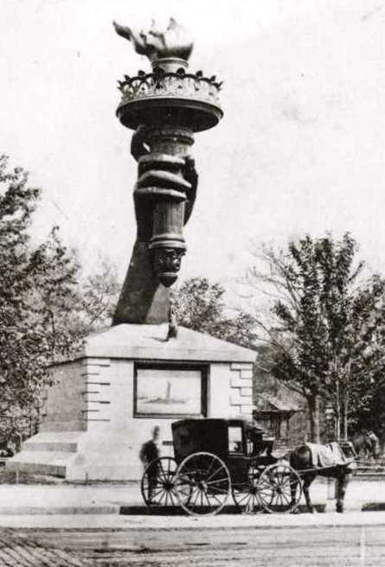

Two years later the statue’s head was displayed in the same way in Paris, giving people a chance to climb up into the head and peek out from the windows in the crown. A lot of enthusiasm was generated, but not as much cash as Bartholdi had hoped for.

In 1883, Congress voted down a bill to pay for the pedestal, and Joseph Pulitzer, publisher of the New York World, was so angry that he launched a campaign in his newspaper. He managed to raise only $133.75 for the pedestal.

By June of 1884, the statue itself was finished, but it stood in a courtyard in Paris because there was no pedestal, and an estimated $100,000 was still needed to complete it. When New York had no funds, Boston, Cleveland, Philadelphia and San Francisco began to compete to have Lady Liberty.

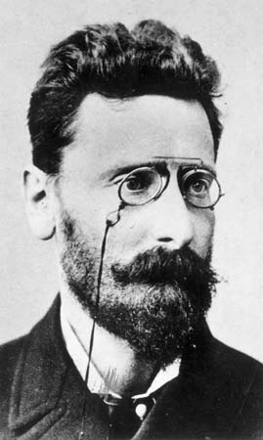

Joseph Pulitzer decided to try again – and his paper had a much bigger circulation by then – he also promised to list the name of any contributor in his paper, no matter how small the donation. “The statue is not a gift from the millionaires of France to the millionaires of America,” he told readers, “but a gift of the whole people of France to the whole people of America. Take this appeal to yourself personally.” And this time, he raised over $52,000 by May 15th.

Another $25,000 was offered by the makers of Castoria, a laxative – but they wanted to right to have their name across the top of the pedestal for one year – the offer was declined.

But by now, ordinary Americans were sending in pennies, nickels and dimes … and they also began buying copies of the World newspaper each day to keep track of the race; it became the most widely read newspaper in the Western Hemisphere.

Finally, on August 11, Pulitzer’s goal was met. “**ONE HUNDRED THOUSAND DOLLARS! TRIUMPHANT COMPLETION OF THE WORLD’S FUND FOR THE LIBERTY PEDESTAL**” the headline read. More than 120,000 people had contributed to the effort, for an average donation of about 83¢ per person.

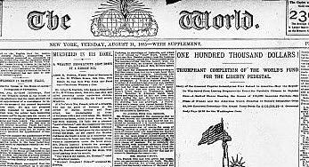

By April 1886 the pedestal was finally finished, and the pieces of the statue itself were put into place. The internal steel and iron framework structure went up first; then the pieces of the statue’s outer skin were attached one by one. Finally, on October 28, 1886, at a ceremony headed by President Grover Cleveland, the statue was opened to the public … more than ten years after the original July 4, 1876 deadline.

The statue was late – **very** late. But better late than never! And it is not only a **KIND** gift to the American people, but a testimony of one man who promised he would do something and then took the responsibility to make it happen! And the **KINDNESS** and generosity of Americans who donated to ensure its completion.



# SPECIAL OPPORTUNITIES

## MESSENGERS OF PEACE

*from* [*http://scouting.org*](http://scouting.org)



**Program Overview**Launched in September 2011, Messengers of Peace is a global initiative designed to inspire millions of young men and women in more than 220 countries and territories to work toward peace. Using state-of-the-art social media, the initiative lets Scouts from around the world share what they’ve done and inspire fellow Scouts to undertake similar efforts in their own communities. The initiative is inspired by the World Scout Committee, administered by the World Scout Bureau, and driven by youth volunteers worldwide.

**Defining Peace**In terms of the MOP initiative, peace encompasses three dimensions:

1. The personal dimension: harmony, justice, and equality
2. The community dimension: peace as opposed to hostility or violent conflict
3. Relationships between humankind and its environment: security, social and economic welfare, and relationship with the environment

Any Scout or Scouter who participates in a project that has had a significant impact on the community in any one of the three dimensions above can qualify as a Messenger of Peace.

**Submitting Projects**Submitting MOP-related projects is easy for BSA units. All they need to do is check the Messengers of Peace box when entering a service project through the Journey to Excellence website: <http://www.scouting.org/Awards/JourneyToExcellence>.

Doing so will generate a unit certificate and add the project to the map on the Messengers of Peace website, <http://scoutmessengers.com>.

**Recognition Item**Any Scout or Scouter who participates in a qualifying project is eligible to wear a Messengers of Peace ring patch around the World Crest on his or her uniform. To purchase these ring patches, a unit representative should take the unit certificate to the local Scout shop or council service center.

**Messengers of Peace Service Project Ideas**Peace is more than the absence of war. It encompasses harmony between individuals, between communities, and between humankind and the environment. A Messengers of Peace service project is defined as any project that touches on one of these dimensions of peace:

1. The personal dimension: harmony, justice, and equality
2. The community dimension: peace as opposed to hostility or violent conflict
3. Relationships between humankind and its environment: security, social and economic welfare, and relationship with the environment



**Here are sample project ideas:**

**Personal Dimension**

* Host a holiday party for children of prison inmates.
* Collect books and magazines for inner-city schools.
* Conduct entertainment programs, including skits and plays, at a nursing home.
* Make and donate gift boxes to be distributed by Feed the Children.
* Assist organizations that provide home maintenance services for those in need.
* Clean a Habitat for Humanity house before the family moves in.

**Community Dimension**

* Create a community prayer garden.
* Replace graffiti with peace-related murals.
* Host conflict-resolution workshops in a local school.
* Plan a sports tournament that brings together kids from different segments of the community.
* Serve as “victims” for a county EMT or first responders training course.
* Assist in the packaging of medical supplies for developing countries.

**Environmental Dimension**

* Clean up a campground, a local park, a river, or a school parking lot.
* Assist with a shoreline-restoration project.
* Collect and dispose of household chemicals, batteries, and other potentially dangerous waste products from the residences of shut-ins.
* Remove invasive species and plant native trees in a park.
* Volunteer at a community recycling center.
* Clear brush from fire buffer zone.

For tips on conducting successful projects, visit [www.scouting.org/scoutsource/Awards/JourneyToExcellence/unit_tips.aspx](http://www.scouting.org/scoutsource/Awards/JourneyToExcellence/unit_tips.aspx).

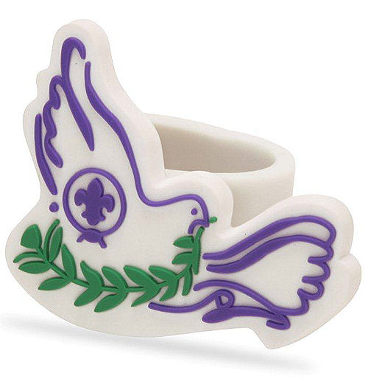

# CUB GRUB

**Cub Grub Cookbook**

This is a really great cookbook for Cubs -

<http://balboaoaks.bsa-la.org/download/blog/Cub%20Grub%20Cookbook.pdf>

You can save a copy on your PC by selecting   
**File, Save As...** in your web browser's menu bar.

**Drugstore Wrap**

*Oregon Trail Council*

*This method of wrapping will seal in juices and hold steam while cooking foil meals and desserts. You can use cutout pieces of craft foam to represent food items while practicing.*

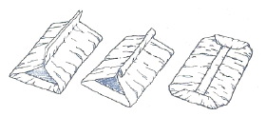

* Place the food in the center of the foil.
* Bring the two long sides of the foil up together over the food;
* Fold down in a series of overlapping folds to allow for heat and expansion.
* Fold each of the short ends over several times and crimp closed.

**Easy Foil Packet Meals**

*Oregon Trail Council*

**Materials:**

Charcoal or gas grill (adult supervision required),

heavy duty foil, cut into pieces approximately 12” by 18”

**Ingredients:**

2 pounds lean ground beef

1 onion, sliced

1 (16-ounce) package baby carrots

4 potatoes, peeled and sliced

Seasoned salt to taste

Salt and black pepper to taste

Water

Other condiments:

Worcestershire sauce,

barbecue sauce,

salsa,

mustard,

ketchup

**Directions**

* Preheat grill to medium-high heat.
* Have boys wash their hands,
* Form ground-beef patties, and place each patty on a piece of foil. (If necessary, use double layers of foil.)
* Layer each hamburger patty with onion slices, carrots, and potato slices.
* Season to taste with seasoned salt, salt, and pepper.
* Add any other condiments on top.
* Add a tablespoon or so of water
* Wrap foil around food and seal each packet tightly, using the drugstore wrap.
* Grill 30 minutes, or until the potatoes are tender.
* Carefully open each packet (the escaping steam will be very hot) and serve.

**Alternatives:**

Chicken breast and fish also cook well in foil.

**Baked Apples**

*Oregon Trail Council*

**Ingredients:**

apples,

aluminum foil,

fillings (see below)

**Directions:**

* Core apple and add fillings such as marshmallow, sugar, fruit, cherries, chocolate crops, or syrup.
* Completely cover with aluminum foil and
* Seal the edges.
* Place in coals and leave for 10 to 15 minutes.

**S’mores.**

*Oregon Trail Council*

Roast marshmallows on a stick over coals until soft.

Place on half a graham cracker.

Add one or two chocolate squares.

Top with half a graham cracker.

**Cake in an Orange.**

*Oregon Trail Council*

Hollow out an orange.

Mix a cake mix per directions and pour into the hollowed orange peel until two-thirds full.

Cover with aluminum foil and cook in coals for 15 minutes.

**Pig in a Blanket.**

*Oregon Trail Council*

Skewer hot dogs on sticks or a barbeque fork.

Wrap them with half of a refrigerated, canned biscuit.

Cook over coals until the biscuit is browned and the hot dog is hot.

**A Campfire You Can Eat**

*Sam Houston Area Council*

**Ingredients –**

12” flour tortillas

Tootsie rolls

Red licorice rope

Mini pretzel sticks

Peanuts

White grape juice

Peanut butter

Hot Cocoa powder

Fried noodles

Candy corn

**Directions –**

1. Clear a space on a table to make a safe fire.
2. Lay down a tortilla fire base and wrap a licorice rope safety circle around the tortilla about an inch from the edge.
3. Build a peanut rock ring halfway between the safety circle and the center of the fire base.
4. Spread a circle of peanut butter in the center of the fire base,
5. Then lay a small handful of fried noodles on top for kindling.
6. Lay Tootsie roll logs around the peanut butter circle.
7. Use mini pretzel sticks as fuel wood to build a teepee inside the ring of logs and over the kindling, sticking the pretzels into the peanut butter at a 45-degree angle.
8. Add another layer of logs, setting them across the corners of the first layer to form a box around the teepee.
9. Lay a few more pieces of fuel wood across the logs.
10. Make sure buckets of water (glasses of grape juice) and dirt (hot cocoa powder) are nearby to put out the fire if necessary.
11. Then, light the fire by adding candy corn flames.
12. After the Cubmaster approves the fire, throw dirt (cocoa powder) on the fire to put it out. AND – Eat!

**Wormy Apple Mix**

*Utah National Parks Council*

**Directions**

8.5 ounces Gummy Worms

6 ounces dried apple chunks

1 cup dry roasted peanuts

1 cup miniature marshmallows

1 cup raisins

**Directions**

* Mix all ingredients.
* And divide evenly into plastic bags.

**OUTDOOR COOKING**

*Catalina Council*

Cooking and eating can be an outdoor adventure too. You don't have to camp out to get a taste of the camping adventure. There is just something about outdoor cooking that is special.

Cooking outdoors requires a different set of rules and equipment. Even cooking a hot dog or marshmallow just right without burning it can be a real challenge.

**Charcoal Stove**

*Catalina Council*

**Materials:**

Tin can (#10 or larger)

Roll-type can opener

Punch opener

Wire for handle

Three pieces sturdy wire screen

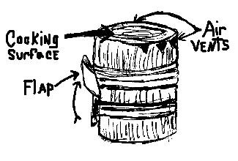

***Note - This picture does not match directions but gives you an idea. I could not find a good picture to use. CD***

**Directions:**

1. Remove top of can with roll-type can opener.
2. Punch air holes with punch opener all around the can near top and bottom.
3. Stick ends of wire for handle through two of the holes at top and twist to make a handle.
4. Push wire screen half way down into can to make a grate. This will hold the charcoal near top for cooking and keep air under charcoal. To keep screen from slipping, cut second piece of screen into a coil, and put between grate screen and bottom of stove.
5. Make a stove top out of the third piece of wire screen. This supports your hamburger or the cook pot.

**To use:**

* Set the stove on cleared ground and put tinder on the grate.
* When tinder is burning briskly, drop charcoal into fire.
* Swing the stove by the handle now and then to keep the charcoal burning.

**Bug Snacks:**

*Chief Seattle Council*

**Ants on a Log:**

* Spread peanut butter or cream cheese on celery sticks.
* Add raisins or cranberries for “ants.”

**Ants on a tire:**

* Core apples, and slice into rings.
* Spread peanut butter or cream cheese on the rings.
* Add raisins or dried cranberries for “ants”.

**Peanut Butter Play Dough Bugs**

* Make a recipe of peanut butter play dough.
* Boys can use straight pretzels, small regular shaped pretzels, thin licorice, raisins, M & M’s , etc. to add antennae, eyes, legs, spots, and stripes, to their bugs.

Play dough recipes: <http://www.makingfriends.com/pro_edible.htm>

**Jell-O Snakes (or worms)**

**Ingredients**

1 ½ cup apple juice

3 oz. package flavored gelatin

1 envelope unflavored gelatin

5 ice cubes

small Ziploc bags

**Directions**

1. Pour half the juice into saucepan. Heat until boiling;
2. Remove from heat. Add gelatin, and stir until dissolved.
3. Pour remaining apple juice into mixing bowl. Add unflavored gelatin, and stir until dissolved.
4. Add mixture to hot apple juice.
5. Add ice cubes, and stir until melted.
6. Refrigerate until the consistency of pudding, about 10-15 minutes.
7. Spoon gelatin into Ziploc bags.
8. Cut ¼ inch off the corner of the bag.
9. Squeeze a wavy line of gelatin onto a foiled cookie sheet.
10. Chill in refrigerator about 2 hours.
11. To keep snakes firm while serving, place them on a plate over ice cubes.

**Backyard Ice Cream**

*Baltimore Area Council*

**Ingredients**

1 - 1 pound coffee can w/lid  
1 - 3 pound coffee can w/lid  
2 10” squares aluminum foil  
1 pkg. instant pudding  
1 qt. crushed ice

½ pint milk

1 - 13 oz. can evaporated milk

1 roll duct tape

1 pound rock salt (any flavor)

*For additional flavoring use fruit, chocolate chips, nuts, etc.*

**Directions**

* Into the one pound can add the pudding mix, evaporated milk and enough fresh milk to fill can to the ¾ point. Stir very well.
* Place aluminum foil squares over can top and press plastic lid on.
* Secure lid with several wrappings of duct tape across top of lid and several more holding the lid on the sides.
* Place shallow layer of crushed ice into the 3 pound can.
* Sprinkle with rock salt.
* Place one-pound can in three pound can.
* Alternate layers of crushed ice and rock salt, filling the three-pound can.
* Secure lid with foil and cut tape as before.
* Roll or otherwise agitate the can for 20 minutes (perfect opportunity for a game!).
* Remove the ice cream and enjoy. Makes about a quart.

**Nelson's Stew**

*Catalina Council*

**Ingredients:**

Box of macaroni and cheese

1 can of chunky ham

**Directions:**

1. Heat water to boiling.
2. Add macaroni and cook until soft.
3. Make macaroni and cheese in accordance with directions on box.
4. Crumble can of chunky ham into mixture, mix thoroughly.

This is easy. Feeds 2 scouts per box of mac and cheese, 1 can of ham for each 2 boxes of macaroni.

***I remember a card from the back of Mac and Cheese boxes when I was a SM that gave various meat and vegetable combinations to add to the box mix. My Scouts loved those meals. Wish I still had the card. CD***

**Camp Stroganoff**

*Catalina Council*

**Ingredients:**

1-1/2 to 2 pounds ground beef

Onion soup mix

2-3 tablespoons of ketchup

1 cup sour cream

1 can cream of mushroom soup

Noodles

**Directions:**

1. Bring pot of water to a rolling boil and cook noodles until done.
2. Brown meat and drain off grease.
3. Add remaining ingredients and simmer until meat is tender. If necessary, thin sauce with a little milk.
4. Serve over cooked noodles.

**Scout Tacos**

*Baltimore Area Council*

**Ingredients**

1 pkg. Taco Seasoning mix  
2 pounds hamburger  
1 15 oz. can Ranch Style Beans  
1 medium onion, chopped

Lettuce

Tomatoes

Cheese, shredded

**Instructions**

* Sprinkle salt in bottom of Dutch oven.
* Follow directions on Taco Seasoning mix.
* Be sure not to add too much water.
* Add beans.
* Cook until beans are hot.
* Serve mixture on Doritos or Fritos.
* On top, sprinkle lettuce, tomatoes, cheese & onions.

**Just A Little Bit Different Trail Mix**

*Utah National Parks Council*

**Ingredients**

2 cups Quaker Oat Squares

1 cup small Pretzels

1 cup Almonds

½ cup Honey Roasted Peanuts

1 or 2 small packages of M&M’s

1 cup Craisins

**Directions**

* Mix them all together and
* Divide evenly into plastic baggies.

**Dutch Oven Cobbler**

**Ingredients**

1 White or Yellow cake mix   
1½ sticks butter or margarine  
brown sugar  
cinnamon  
2 cans apple filling (or whatever fruit pie filling you prefer)

**Instructions**

* Put pie filling into Dutch oven together with about 3/4 can of water.
* Sprinkle cinnamon over apples.
* Sprinkle dry cake mix evenly into Dutch oven.
* Do not mix or stir.
* Cut butter into l/4 thick squares and cover cake mix.
* Sprinkle cinnamon and brown sugar on top of butter.
* Place lid on Dutch oven. Put 4 pieces of hot charcoal under Dutch oven and 12 pieces on top of Dutch oven.
* Cook about 45 minutes or until you can’t resist the aroma.
* Peach cobbler can be made by using two cans of sliced peaches (29 oz. can) and eliminating the water.

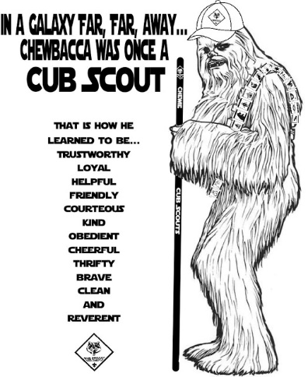**A Pocket Banquet for One**

*Utah National Parks Council*

Here’s a complete meal for one that you can carry in your pocket… and you can prepare all of it before you leave for a hike. Then all you do is add water where necessary, heat it and feast!

**Soup –**Dehydrated soup (like Lipton’s Chicken Noodle – or your preference) packaged in a piece of strong foil. The foil can be molded into a soup bowl when ready to eat just add water and heat.

**Cocoa –**Pack enough instant cocoa mix for two or three cups in small envelopes of foil. Biscuits – Carry enough instant biscuit mix wrapped in foil to make two biscuits. Mix necessary amount of water right in the same foil. Puncture with knife so steam can escape when you put it next to the fire to bake.

**Main dish –**Wrap a quarter pound of beef steak, one potato, one onion, and one carrot (Potato, carrot, and onion cut into small pieces) in a piece of foil. Remember to add seasoning, a tablespoon of water +/-, and a pat of butter. Place foil package on coals. Roll wrap to seal liquids inside. Cook for ten minutes.

**Dessert –**Core one apple, add cinnamon and sugar. Wrap it in foil. Place it on coals, by the time you are ready for dessert, it will be baked, ready to eat.

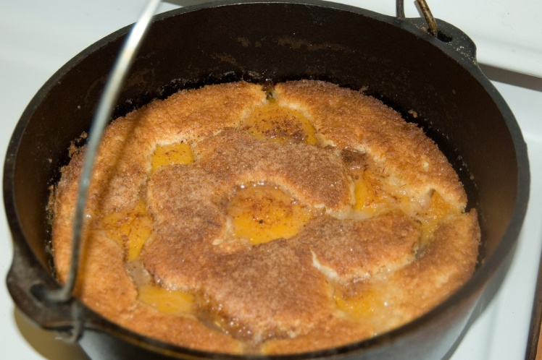

ONE LAST THING

## MY SCOUT SHORTS.

*Mark Diienno, Cubmaster Emeritus, Garden State Council, and a wise old OWL   
who has earned the Unit Leader Award of Merit*

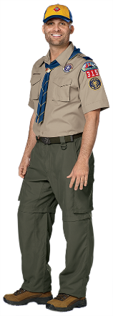I bought my first uniform in 2007.   
It had to be perfect.

I had drunk the .

I remember walking into my first meeting wearing my perfect uniform.

I felt funny. Like I didn’t belong in it. I suppose those of us who were never scouts, but had chosen to be leaders have all been there.

The Pack Leader looked up at me and was shocked to see me in full uniform. We had just resurrected the unit, and he had not quite got the full uniform down yet.

“You are gunning me!”, he exclaimed.

**And my nickname was born -   
Gunnar D.**

The nickname fit me a little different back then.

I had purchased the nylon/polyester mix pants as part of the original uniform. I still have them. Wear them and **Love them**.

They are an amazingly durable part of the uniform. No real holes to speak of, although the pockets are showing signs of wear.

When I first put the uniform on we were a small unit. 7 boys.

Didn’t know much about what program was.

I didn’t know the Law of the Pack or the Cub Scout Promise.

I felt strange wearing it as I walked into Wawa, feeling like everyone was staring at me. Like I didn’t deserve to be wearing it. The real fact of the matter was I hadn’t made any memories in it yet. It wasn’t relevant to me.

**Yet.**

But we kept trying. And trying is all you need.

We grew. We took training

And our pack was soon 25 strong. Patches were now becoming part of my shirt.

My uniform was becoming part of me. Telling my story.

**But my pants?  
Never changed.**

Six pockets that often times were empty, but at other times, seemed to be holding just the right things to get me through.

Then the centennial uniform was unveiled.

And yes, I ran to the Scout store to get   
my updated version of the uniform.

**Canvas pants.   
Man! This is an upgrade!**

And I placed my original uniform in my closet.

I looked spiffy.

But the pants. They were heavy.

When they got wet? They stayed wet.

So I came up with a plan.

Wear the spiffy uniform to meetings and   
camp in the original synthetic pants.

**I felt like a genius. .**

When camping the original switchbacks fit my needs perfectly. I’m the kinda guy who pretty much wore the same clothes throughout for the weekend. And the synthetic pants were more than happy to oblige.

I wore them all day. Everyday.

**If they got wet?  
Dry in ten fifteen minutes.**

The best part was bed time. Unzip the bottoms and get into your bunk. They were light. Easy to sleep in.

Perfect for a guy like me who didn’t mind his own odor.

**And bam.   
I was a scout!!!**

If I had the urge during the night? I was ready.   
I was DRESSED.

I always thought by sleeping in my beloved shorts I was living to the Motto – Be Prepared.

When I awoke in the morning all I need do is put on my socks and boots and I was good go.

Now when waking up in synthetics you are kinda a wrinkled mess. Like wearing tin foil pants

**But these are magic.   
Within ten fifteen minutes,   
they are wrinkle free.**

Why aren’t all shorts like these?

**These things are amazing.   
Except near fire.**

Whoever designed these didn’t think of possibility that a scout could be close to fire.

**Um duh**

I have seen the effects on others who, like a moth drawn to a light, can’t help but get close to the campfire.

The pants do the shrinky dink kind of thing.

They get hard

They die.

Ok the shorts aren’t quite perfect.   
You must pick and choose your spots.

**So if a campfire is planned,   
the canvas version is worn.**

But honestly, this is a small part of the Scout experience time wise.

So now to the present.

**I still have the original scout pants.   
They are my favorite.**

Well the shorts are.

If I wear the full pants it is not that hard to see that I have worn and washed the shorts more than the bottoms and my pants are now two toned green.

So I look like a salamander

But to the savvy scouter, they know and share my experience with my beloved synthetic switchbacks.

They get that I have worn these Shorts.   
**In civilian life.**

**Like Levis.   
I work out in them.**

**I do everything in them.**

I had coffee with my adult daughter the other morning. I came out on my back deck in my beloved shorts.

**She looked up me and said   
“Nice shorts”.**

I felt cool

For a moment.

Then I realized she didn’t quite share the same affection for my pants as I did.

She had taken a shot at me.

**And at that moment I realized   
I don’t care in the least**

I had just worn these things 7 days straight   
and she didn’t have a clue.

I win.

**I love my scout shorts.**

